|  |  |
| --- | --- |
|  | |
|  | |
|  |  |

|  |  |
| --- | --- |
| Publication type: |  |
| Publication number: | ACC |
| Title: |  |
| Subject: |  |
| Issue: | 1.4.12 |
| Publication date: | 12 September 2013 |
| Total number of pages: | 133 |
| Author: |  |
| Quality Control: |  |

Table of contents

Page #

2. Figures 7

3. References 12

4. Introduction 13

5. About the Operating Manual 13

6. Safety instructions 15

7. Revision history 15

8. Human Machine Interface 16

8.1 Taskbar 16

8.1.1 Mimics and screens 17

8.2 User rights 17

8.2.1 Instruments and indicators 18

8.2.2 Analogue, digital and graphical instruments 18

8.2.3 Indicators 19

8.2.4 Bar graphs 19

8.2.5 Diagrams 20

8.2.6 Buttons/switches 20

8.2.7 Meters 21

8.3 Config list 21

8.4 Mimics 22

8.4.1 General 22

8.4.2 Free adjustable mimics 23

8.4.2.1 Building the mimic 24

8.4.3 Color usage 26

8.4.4 Colour coding 27

8.4.5 Symbols 27

8.4.6 Control elements 28

8.5 Functional description 32

8.5.1 Measuring and control of Fresh Cooling Water (FCW) temperature 32

8.5.2 Alarm and monitoring of main engine exhaust gas system 34

9. Duty alarm system 35

9.1 Introduction 35

9.2 General 35

9.3 Design principle 36

9.3.1 Alarm groups 36

9.3.2 Alarm types 36

9.3.2.1 Alarm detection for analogue signals 36

9.3.2.2 Alarm detection for on/off (two state) signals 36

9.3.2.3 Alarm detection for on/off signals with line check 37

9.3.3 Alarm inhibits 37

9.3.4 Attended alarm mode 37

9.3.5 Unattended alarm mode 37

9.4 How an alarm is displayed 38

9.4.1 How to acknowledge an alarm 39

9.4.2 When an alarm is not acknowledged within a specific period of time 39

9.4.3 How to silence an alarm (not at ECR) 39

9.4.4 When will an alarm disappear 39

9.4.5 Duty Alarm Panel (DAP) 41

9.4.6 Controls and indications 41

9.4.6.1 Call button 42

9.4.6.2 On-duty indication 42

9.4.6.3 Duty select button 42

9.4.6.4 Panel active button 42

9.4.6.5 On-duty selection 42

9.4.6.6 Watch safety timer 43

9.5 Duty Alarm Panel functionalities 45

9.6 On duty select procedure 45

9.7 Alarm acknowledge procedure 46

9.8 Call function 46

10. Personnel alarm 48

10.1 General 48

10.1.1 Release station 48

10.1.2 Alarm Panel 49

10.1.3 BNWAS 50

10.2 Alarm monitoring and control process 50

11. Setting and adjustment 51

11.1 Users 51

11.1.1 User name 51

11.1.2 Login at startup 51

11.1.3 Password 52

11.1.4 Rights 52

11.1.5 Add / Remove 53

11.2 Field settings 54

11.2.1 Alarm 55

11.2.1.1 Alarm levels 55

11.2.1.2 Inhibit Properties 56

11.2.1.3 Auxiliary Properties 57

11.2.2 Min/Max 58

11.2.2.1 Instrument range 58

11.2.2.2 Setpoints 60

11.2.2.3 Setpoint delay 60

11.2.2.4 Decimals 60

11.2.2.5 Default unit 60

11.2.2.6 Filter 61

11.2.2.7 Pulse/Request time 61

11.2.3 Tune 61

11.2.3.1 Tune table 61

11.2.3.2 Result 62

11.2.3.3 Sender 62

11.2.4 Comment 63

11.2.4.1 Group label 63

11.2.4.2 Group label logbook 63

11.2.4.3 Field label 63

11.2.4.4 Field label instrument 64

11.2.5 Auto Switch 64

11.2.5.1 General 64

11.2.5.2 Autoswitch Method 64

11.2.6 Log 66

11.2.6.1 Logging 66

11.2.6.2 Time indication 66

11.2.6.3 Interval 66

11.2.6.4 Filename 66

11.2.7 Logging with trending 66

11.3 Alarm stations 69

11.3.1 Station Matrix 69

11.3.1.1 This station 69

11.3.1.2 Is fallback for 70

11.3.1.3 Show all alarm stations 70

11.3.1.4 Alarm group rights/Duty alarm rights 70

11.3.1.5 Adjustments 70

11.3.1.6 How to set 70

11.3.1.7 Background 71

11.3.2 Alarm Panels 72

11.3.3 Alarm groups 73

11.3.4 Alarm Settings 74

11.4 Preferences 75

11.4.1 General 75

11.4.2 System Settings 75

11.4.3 Field Settings 75

11.4.4 Ship heading reference 76

11.4.5 SMS service (ship name) 76

11.4.6 SMS service (phone active A & B) 76

11.4.7 SMS service (SMS PIN) 76

11.5 Taskbar 76

11.5.1 General 76

11.6 GPS/NMEA 78

11.6.1 General 78

11.6.2 GPS calculates the position in/The position is shown in 78

11.6.3 Trace of received NMEA data 78

11.7 Configuration 79

11.7.1 General 79

11.8 License 79

11.9 Serial 79

11.9.1 General 79

11.9.2 COM ports 80

11.9.2.1 COM port assignment 80

11.9.3 Serial LAN ports 83

11.9.3.1 Serial LAN server 84

11.9.3.2 Type (Moxa UC-711X) 84

11.9.3.3 Type (V-Linx ESR-904) *Obsolete* 85

11.9.3.4 Type (ICPdas i7540D) 86

11.9.4 CAN ports 87

11.9.5 Overview connected devices 88

11.9.6 IP-Address standardization 89

11.10 Wago 89

11.10.1 General 89

11.10.2 Adding a field to the Wago 91

11.10.3 Wago “Type” explanation 92

11.10.4 Type and behavior 93

11.10.4.1 Alarm 93

11.10.4.2 Alarm Buzzer 93

11.10.4.3 Alarm Status 94

11.10.4.4 Auto 94

11.10.4.5 Closed 94

11.10.4.6 Failure 94

11.10.4.7 High 94

11.10.4.8 High Level 94

11.10.4.9 Impulse 94

11.10.4.10 Lamp 94

11.10.4.11 Low 94

11.10.4.12 Low Level 95

11.10.4.13 Off Lamp 95

11.10.4.14 On Lamp 95

11.10.4.15 Open 95

11.10.4.16 Pending 95

11.10.4.17 Pulse 95

11.10.4.18 Push 95

11.10.4.19 Ready 95

11.10.4.20 Remote 95

11.10.4.21 Request 95

11.10.4.22 Reset (Request) 95

11.10.4.23 Running 96

11.10.4.24 Running Hours 96

11.10.4.25 Set (Request) 96

11.10.4.26 Standard 96

11.10.4.27 Standby 96

11.10.4.28 Status 96

11.10.4.29 Switch 96

11.10.4.30 Timeout 97

11.10.4.31 Too High 97

11.10.4.32 Too High Level 97

11.10.4.33 Too Low 97

11.10.4.34 Too Low Level 97

11.10.5 Wago Device Manager 97

11.10.6 Wago calibration 100

11.11 Network 104

11.12 System Layout 104

11.13 Soft PLC 105

11.13.1 General 105

11.13.1.1 Basics 105

11.13.2 Simple example 105

11.13.2.1 Start 105

11.13.2.2 Control 109

11.14 Tank Tables 109

11.14.1 General, 109

11.14.2 types of sensors 109

11.14.2.1 Floating sensor 109

11.14.2.2 Capacitive sensor 109

11.14.2.3 Pressure sensor 109

11.14.3 111

11.14.4 Inserting sounding tables 111

11.14.4.1 Tank Group 112

11.14.4.2 Excel import 112

11.14.4.3 Import from excel 115

11.14.5 Trim and List 116

11.14.5.1 Roll and Pitch in the Tank Table 117

11.14.5.2 Trim and list in Excel 119

11.15 WatchIO 121

11.16 Logbook 121

11.16.1 General 121

11.16.1.1 Logbook colours 121

11.16.2 Logbook functionalities 122

11.16.3 Buttons 123

11.16.3.1 Scroll buttons 123

11.16.3.2 Time period button 123

11.16.3.3 Alarms from all stations button 123

11.16.3.4 Alarm button 124

11.16.3.5 Switching button 124

11.16.3.6 Network button 124

11.16.3.7 Serial communication button 125

11.16.3.8 System button 125

12. Performance 126

12.1.1 Preface 126

12.1.2 Modules 126

12.1.3 Memory 127

12.1.4 Network 128

12.1.5 IP Owner List (which OWS is handling which ip’s) 129

12.1.6 IP 130

12.1.7 Serial 131

Figures

Figure 8‑1: NavVision® taskbar 16

Figure 8‑2: Analogue/digital/graphical instruments 18

Figure 8‑3: Indicators 19

Figure 8‑4: Bar graph display 19

Figure 8‑5: Trend diagrams 20

Figure 8‑6: Buttons 20

Figure 8‑7: Meter 21

Figure 8‑8: Config list 21

Figure 8‑9: Electrical distribution mimic 22

Figure 8‑10: Tank level mimic 22

Figure 8‑11: Mimic button taskbar 23

Figure 8‑12: Empty Mimic 23

Figure 8‑13: Edit Mode 24

Figure 8‑14: Edit Mode Window 24

Figure 8‑15: Mimic Option Window 25

Figure 8‑16: example mimic options 26

Figure 8‑17: Mimic layout 28

Figure 8‑18: Measuring and control of FCW temperature 33

Figure 8‑19: Exhaust gas temperature measurement 34

Figure 9‑1: Alarm groups 36

Figure 9‑2: Alarm scroll buttons 36

Figure 9‑3: Alarms on alarm viewer and taskbar 38

Figure 9‑4: One acknowledged and three unacknowledged alarms (incl. GEA) 39

Figure 9‑5: typical alarm sequence 40

Figure 9‑6: Duty Alarm Panel (DAP) 41

Figure 9‑7: Alarm and status area 41

Figure 9‑8: Alarm groups 41

Figure 9‑9: Call button / on-duty indication / duty select button 42

Figure 9‑10: Panel active button 42

Figure 9‑11: Watch safety timer 43

Figure 9‑12: Watch safety timer (remaining time indication) 43

Figure 9‑13: Bridge watch 43

Figure 9‑14: Operating buttons 44

Figure 9‑15: On duty indication 44

Figure 9‑16: Bridge watch safety timer 44

Figure 9‑17: Engine room watch safety timer 44

Figure 9‑18: Engine room watch button 44

Figure 9‑19: Call button 44

Figure 9‑20: Acknowledge button 44

Figure 9‑21: Panel active button 45

Figure 9‑22 Duty Alarm Panel (on duty select) 46

Figure 9‑23 Duty Alarm Panel (call function) 47

Figure 10‑1: Deadman Switch Password 48

Figure 10‑2: Release station 49

Figure 10‑3: Alarm Panel 49

Figure 10‑4: BNWAS Panel 50

Figure 11‑1: Users 51

Figure 11‑2: Rights 52

Figure 11‑3: Add / Remove 54

Figure 11‑4: Field settings 54

Figure 11‑5: Alarm settings 55

Figure 11‑6: Alarm example 56

Figure 11‑7: Inhibit Properties 56

Figure 11‑8: Inhibit When 57

Figure 11‑9: Inhibit When 2 57

Figure 11‑10: Inhibit when 3 57

Figure 11‑11: Min/Max settings 58

Figure 11‑12: Engine 1 oil pressure indicator (0 - 30 bar) 59

Figure 11‑13: Instrument pointers 59

Figure 11‑14: Zone marking 60

Figure 11‑15: Decimals 60

Figure 11‑16: Default unit 61

Figure 11‑17: Tune table 62

Figure 11‑18: Sender box 63

Figure 11‑19: Comment 63

Figure 11‑20: Autoswitch 64

Figure 11‑21: Auto Switch Conditions 65

Figure 11‑22: Auto Switch condition 65

Figure 11‑23: Logging 66

Figure 11‑24: Trending instrument 67

Figure 11‑25: Selection boxes 67

Figure 11‑26: time line 67

Figure 11‑27: Trending adjustments 68

Figure 11‑28: Saved trending file 68

Figure 11‑29: Alarm stations 69

Figure 11‑30: Alarm station settings 71

Figure 11‑31: Select by dragging 71

Figure 11‑32: Alarm Panels 73

Figure 11‑33: Alarm Groups 74

Figure 11‑34: Alarm Settings 74

Figure 11‑35: Preferences 75

Figure 11‑36: Taskbar menu 77

Figure 11‑37: viewer group 78

Figure 11‑38: License 79

Figure 11‑39: COM ports 80

Figure 11‑40: Drop-down menu (device interfaces) 80

Figure 11‑41: COM port assignment 81

Figure 11‑42: additional configuration 81

Figure 11‑43: Comm Port Settings 82

Figure 11‑44: Serial LAN ports 83

Figure 11‑45: Type (Moxa) 84

Figure 11‑46: Type (V-Linx ESR-904) 85

Figure 11‑47: Type (ICPdas i7540D) 86

Figure 11‑48: Interface 87

Figure 11‑49: Standard 87

Figure 11‑50: Overview connected devices 88

Figure 11‑51: Wago configuration 90

Figure 11‑52: Wago expanded view 91

Figure 11‑53: Sensor-window 92

Figure 11‑54: Sensor type list 93

Figure 11‑55: Wago Device Manager 98

Figure 11‑56: Device Manager 99

Figure 11‑57: Operating mode switch (Wago) 100

Figure 11‑58: Calibration 101

Figure 11‑59: Graph (WAGO calibration) 102

Figure 11‑60: Graph Calibrated 103

Figure 11‑61: Network 104

Figure 11‑62: Soft PLC 105

Figure 11‑63: SoftPLC Rename 106

Figure 11‑64: SoftPLC pop-up 107

Figure 11‑65: SoftPLC Assign Field 108

Figure 11‑66: SoftPLC first Line 108

Figure 11‑67: SoftPLC First Line_2 108

Figure 11‑68: Tank Pressure Sensor 110

Figure 11‑69: Tank Tables 111

Figure 11‑70: Tank Group Drop Down 112

Figure 11‑71: Filling in tank tables 112

Figure 11‑72: Excel tabs 113

Figure 11‑73: Example Sounding Table 113

Figure 11‑74: Excel sheet import list 114

Figure 11‑75: Excel list sorted 115

Figure 11‑76: Imported Table 116

Figure 11‑77: Roll and Pitch 117

Figure 11‑78: Max Trim 117

Figure 11‑79: Max List 118

Figure 11‑80: Trim/List example 118

Figure 11‑81: trim and list excel example 119

Figure 11‑82: Tank Table excel Trim and List import 120

Figure 11‑83: Logbook button 121

Figure 11‑84: Logbook colours 122

Figure 11‑85: Scroll buttons 123

Figure 11‑86: Time period button 123

Figure 11‑87: Alarms from all stations button 123

Figure 11‑88: Alarm button 124

Figure 11‑89: Switching button 124

Figure 11‑90: Network button 124

Figure 11‑91: Serial communication button 125

Figure 11‑92: System button 125

Figure 12‑1: Performance 126

Figure 12‑2: Memory 127

Figure 12‑3: Network 128

Figure 12‑4: IP Owners List 129

Figure 12‑5: Performance > IP 130

Figure 12‑6: Serial 131

Figure 12‑7: Additional Serial Data 132

Figure 12‑8: Communication Diagnostics 1 133

Figure 12‑9: Communication Diagnostics 2 134

Figure 12‑10: Latest version 135

**NOTICE**

**This document contains proprietary information.**

**No part of this document may be photocopied, reproduced or translated into another language without the prior written consent of   
Free Technics B.V.**

References

Not applicable.

Introduction

The Operating Manual contains all essential information for the user to make full use of FT NavVision®. This manual includes a description of the alarm functions, monitoring functions, control functions and additional capabilities. Also described are contingencies and alternate modes of operation, and step-by-step procedures for system access and use.

About the Operating Manual

This manual contains the following sections:

* Section “Safety instructions” presents warning, caution and note information, which the user should pay attention to.
* Section “Human Machine Interface” contains explanation on the look and feel of the visible part of NavVision®.
* Section “Duty Alarm System” explains how to work with the AM(C)S system and how the different parts are integrated in NavVision®.
* Section “Personal Alarm” explains the work and feel of the different Deadman-systems provided within NavVision®.
* Section “Setting and adjustment” contains the necessary information for initial configuration of NavVision® and for making adjustments later on after commissioning.
* Section “Performance” shows a tool for checking performance of the system on a deeper level.

 *For specific information on interfaces, but also in depth information on here mentioned features, as well as here not mentioned features, we refer you to the specific manuals from NavVision® that can be obtained through Free Technics.*Abbreviations list

AC Alternating Current

AI Analog Input

AM(C)S Alarm Monitoring (and Control) System

AO Analog Output

CAN Controller Area Network

COM Communication

CPU Central Processing Unit

DAP Duty Alarm panel

DC Direct Current

DI Digital Input

DIN Deutsches Institut für Normung

DO Digital Output

DM Dead Man’s

ECR Engine Control Room

FT Free Technics

GEA General Engineers Alarm

GND Ground

GPS Global Positioning System

GRP Group

ID Identification

I/O Input/Output

LAN Local Area Network

LED Light Emitting Diode

LPU Local Processing Unit

MAC Media Access Control

Mbps Megabit per second

NC Normally Closed

NMEA National Marine Electronics Association

NO Normally Open

OWS Operator Work Station

PIN Personal Identification Number

PLC Programmable Logic Controller

Rx Receive

SMS Short Message Service

SRAM Static Random Access Memory

TCP/IP Transmission Control Protocol/ Internet Protocol

TFT Thin Film Transistor

Tx Transmit

UDP User Datagram Protocol

USB Universal Serial Bus

Safety instructions

 *This section provides only a summary of the safety requirements and notes in the following sections. To protect your health and prevent damage to the AM(C)S equipment or vessel, it is essential to read and carefully follow the safety instructions.*

The indications NOTE, CAUTION and WARNING have the following significance:

*NOTE:  
An operating procedure, practice or condition etc., which it is important to emphasize.*

*CAUTION:*

*An operating procedure, practise or condition etc., which, if not strictly observed, may damage AM(C)S equipment or crash NavVision software.*

*WARNING:*

*An operating procedure, practise or condition etc., which, if not carefully observed may result in personal injury or damage to the vessel.*

Revision history

Revisions issued since publication.

|  |  |  |  |
| --- | --- | --- | --- |
| **Issue** | **Date** | **Revision** | **Reason** |
| 1.0 | December 6, 2012 |  | initial release |
| 1.1 | January 4, 2013 | Divers |  |
| 1.2 | February 26, 2013 | Adjustments | Trending |
| 1.3 | June 13, 2013 | Update | Divers |
| 1.4.12 | September 2, 2013 | Minor fixes |  |
|  |  |  |  |

# Human Machine Interface

The NavVision® Operator PC (OPC) Human Machine Interface (HMI) function displays the current state of a physical device on monitor screen by color and/or shape animation.

Moreover when an undesirable state of a device is detected the relevant operator will be notified by means of an audible alarm signal. Messages concerning the alarm are added to the NavVision list of active-/unacknowledged alarms. This list can be displayed on screen by mouse clicking the extensive alarm viewer button, see next paragraph.

The HMI also supports remote platform control. Operators can control the platform(vessel) via the Operator PC (OPC).

The HMI includes the following features (8.1 to 8.5):

## Taskbar

NavVision® main User Interface (UI) element is the taskbar, positioned on top of the main screen. The taskbar is home to the shortcuts to various viewers.

In addition, when an alarm is registered, the right most portion of the taskbar turns a bright red and shows the most recent unacknowledged alarm, the number of active alarms and the total number of unacknowledged alarms. A single mouse click on this portion of the taskbar links to the extensive alarm viewer showing the data for each active alarm such as time, alarm group, status and duration.



Figure 8‑1: NavVision® taskbar

Taskbar features:

* Scroll feature (hold or click the mouse pointer on the taskbar left/right arrow until the desired button is found)
* Mouse clicking a taskbar button will open the corresponding module/viewer
* In case a PC with NavVision is connected to more than one monitor (MTR), a monitor for a particular viewer/module/mimic must be selected (Tools viewer, “Taskbar options”). If no monitor is selected in Taskbar options, a vacant monitor will be selected at random for the viewer/module/mimc. If there’s no vacant monitor, NavVision selects an occupied monitor
* The selected and activated button in the taskbar will obtain a green spot, to indicate that the corresponding viewer/module is activated
* A viewer/module/mimic can be closed by mouse clicking the corresponding taskbar button again. In case a PC with NavVision is connected to only one monitor, a viewer/module/mimic will automatically close by clicking a new taskbar button
* The extensive alarm viewer is opened by mouse clicking the taskbar alarm zone (top right).

### Mimics and screens

The NavVision mimic presentation function provides schematic and graphical overviews of the vessel’s systems like navigation lights, electrical, piping and hydraulic overview.

The screens and mimics presentations are automatically updated with live data of the platform components illustrating components and/or system status.

Via these screens and mimic pages, the operator is able to monitor and control the vessel by using the trackball or touch-screen as a pointing device by selecting elements and their associated commands.

## User rights

NavVision®handles control rights by using log-in credentials (username and password), and assigning rights to these credentials. These rights limit access to the system's configuration, therefore ruling out any edits that may harm the system made by unauthorised crewmembers.

Users can be added, edited or removed. Adding, editing and removing users, together with assigning their rights, can only be done by an administrator, i.e. a top-level user.

For every profile made, permissions can be set. The system is delivered with three pre-configured user-profiles, namely:

1. *Administrator*: has all rights;
2. *Guest*: can only use the available viewers;
3. *Operator*: can only alter display mode and/or units.

Login is required upon system start-up. After start-up, users can log off and log in using a dedicated button on the taskbar.

The rights (configurable) for NavVision® are as follows:

|  |  |
| --- | --- |
| **Rights** | **Effect of rights** |
| Administrator rights | Full access to the system's configuration parameters |
| Personal alarm settings | Settings on the particular DAP[1], for this user only |
| Certified alarm settings | Configuration of global alarm stations |
| Layout of instruments | Edit instrument's display mode (digital, analogue, graphic) |
| Configuration of instruments | Change instrument's assigned field |
| Settings of logging | Enable/disable logging of fields |
| Settings of sliders | Changing the value of sliders |
| Edit layout viewer | Right to edit a mimic of the Layout Group viewer |
| Able to close startup viewer | Right to close all mimics (go to NavVision background) |
| Able to close application | Right to shut down NavVision |
| Settings → Field settings | Access to the Field Settings page in the Tools viewer |
| Settings → Preferences | Access to the Preferences page in the Tools viewer |
| Settings → Taskbar | Access to the Taskbar page in the Tools viewer & configuration of the selectable & default viewers |
| Settings → NMEA/GPS | Access to GPS/NMEA settings page in the Tools viewer |
| Settings → Configuration | Access to the Configuration page in the Tools viewer |

Table 8‑1: NavVision® rights

### Instruments and indicators

Analog data from platform components (measurements) can be displayed by two NavVision attribute types: “Instruments” (see 8.2.2) and “Indicators” (see 8.2.3).

Instruments and indicators are distinguished as follows:

|  |  |  |
| --- | --- | --- |
| **Feature** | **Instrument** | **Indicator** |
| Change configuration | Yes | No |
| Change alarm settings | Yes | No |
| Change unit | Yes | No |

Table 8‑2: Operator configuration features of NavVision instruments and indicators

### Analogue, digital and graphical instruments

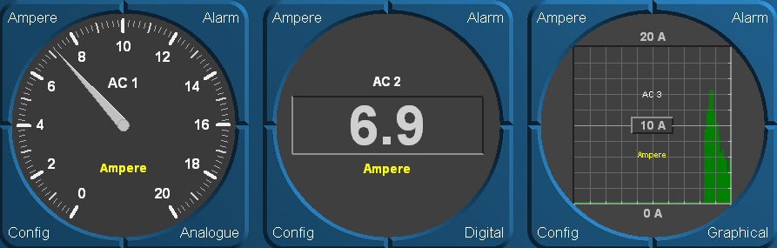

Figure 8‑2: Analogue/digital/graphical instruments

1. **Setting the unit**  
   Mouse clicking the instrument upper left button opens the unit dialog box. All displayed data comes with a certain unit e.g. m/s, km, nm, KN etc. The default unit which was selected during commissioning (or earlier) can be changed when the operator has the proper rights (“Edit layout viewer” rights, Administrator rights, etc.).
2. **Alarm settings**  
   Mouse clicking the instrument “Alarm” button opens the alarm settings dialog box. A “low warning”, “high warning”, “too high alarm”, etc. value can be added or changed.
3. **Choose instrument type**  
   Mouse clicking the instrument lower right button opens the mode dialog box. The instrument can be changed to a different display mode, analogue/digital/graphical.
4. **Configuration**  
   The instrument lower left “Config” button allows you to change the data to be displayed. A list of all analog data in NavVision (measurements, etc.) will appear to choose from.

### Indicators

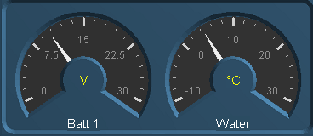

Figure 8‑3: Indicators

NavVision attribute “Indicator” has the same functionality as attribute “Instrument”.

As a rule, indicators are used for values which do not require an accurate reading by the operator. The advantage of indicators is that they take up less space.

Right mouse/trackball clicking on the indicator allows you to change the data to be displayed. A list of all analog data in NavVision (measurements, etc.) will appear to choose from.

### Bar graphs

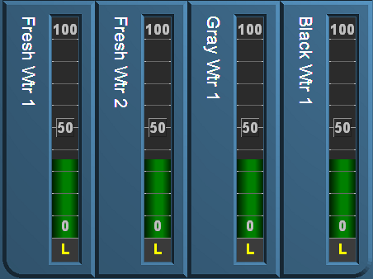

Figure 8‑4: Bar graph display

Tank levels, etc. can also be displayed with bar graphs. Like indicators, bar graphs are configurable and can run both vertically and horizontally.

The colored bars indicate the current levels.

 *By mouse clicking a colored bar, you can change the color of the bar to your liking.*

### Diagrams

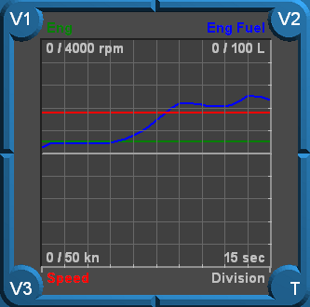

Figure 8‑5: Trend diagrams

NavVision “Diagram” attributes can display data from platform components (measurements) over a longer period of time. With the Diagram attribute buttons V1, V2 and V3 a data selection of max 3 measurements can be made. The diagram time-scale can be changed by clicking the T-button. Each click will enlarge/reduce the scale until it reaches the shortest scale, 15 sec/div. Longest scale is 24 hrs/div.

### Buttons/switches

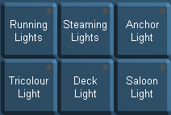

Figure 8‑6: Buttons

With the NavVision buttons, systems can be switched on or off or changes can be made to certain parts of the system. An operator can use the left mouse button to activate a button, by clicking it again, the button will be disengaged.

A small green spot in the relevant button lights up, indicating that the corresponding application is active. As long as the button lights up blue, it means that the software is processing data in order to activate the application. Details of this list are described in the “Config list” (section 8.3).

### Meters

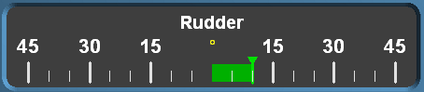

Figure 8‑7: Meter

Meters are used for position information (e.g. rudder position). A deflection to the right and the left are compared to a neutral position (centre of the meter).

## Config list

Basically any instrument allows you to display any type of data. Changes can be done by an operator with sufficient user rights. To change, press the config button (see paragraph 8.2.2) of a particular instrument within the “Config list”, or click the right mouse button on the instrument when no button is visible. The following window appears:

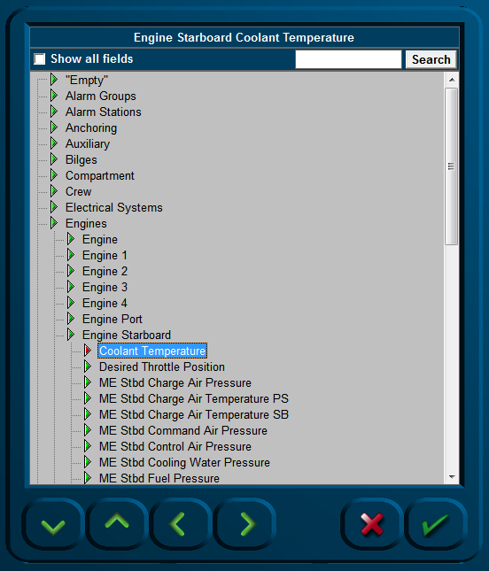

Figure 8‑8: Config list

From this list (1) you can select the type of data you wish to direct to a certain instrument. At the bottom of the list there is a check-box. In case this check-box is not ticked, only those groups will show of which data is being configured. In case the check-box is ticked, all available groups will then be shown.

## Mimics

### General

In general we say that every page that represents a set of values, switches or any other representation of data is a mimic. At this time we work with two kind of mimics. We have the static pages, where we have predefined instruments (see Figure 8‑9 and Figure 8‑10) in which you can alter the data that will be shown in the instrument and we have mimics that are freely adjustable (see Figure 8‑17). In the near future NavVision will only consist of the free adjustable mimics. Up till then we will provide a mix depending on the wishes of the customer.

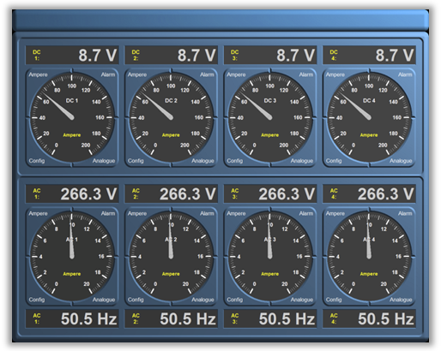

Figure 8‑9: Electrical distribution mimic

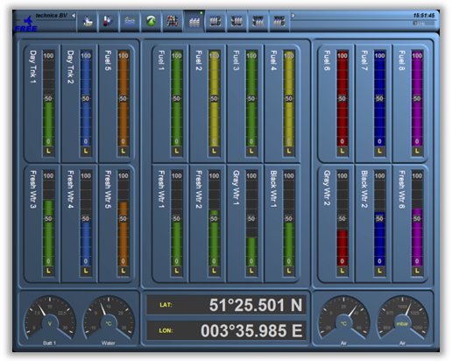

Figure 8‑10: Tank level mimic

### Free adjustable mimics

We will focus here on the free adjustable mimics. Depending of the license the client bought, you can have as many mimics as you like. They are represented in the taskbar under the mimic button (see Figure 8‑11). Once you open that you can choose the mimic number and an empty mimic will appear (see Figure 8‑12).

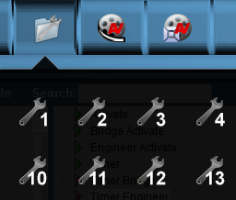

Figure 8‑11: Mimic button taskbar

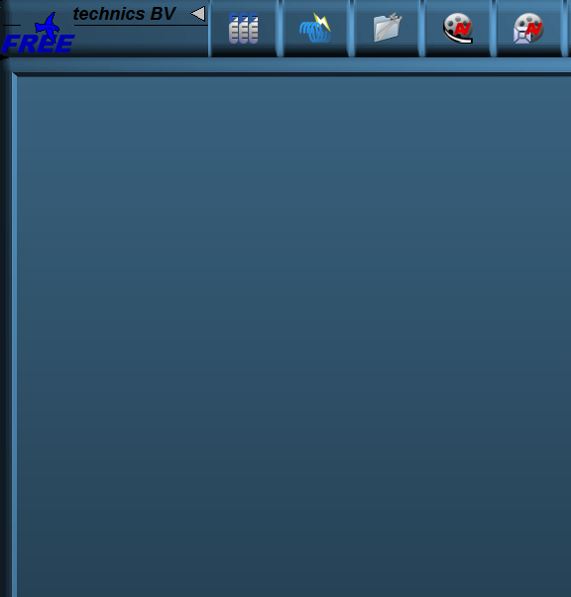

Figure 8‑12: Empty Mimic

#### Building the mimic

To start building the mimic you can right-click anywhere on the empty mimic. There will be an option to choose to open the edit mode (see Figure 8‑13). Once opened you get a new window (see Figure 8‑14).

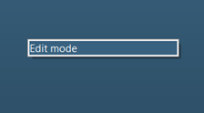

Figure 8‑13: Edit Mode

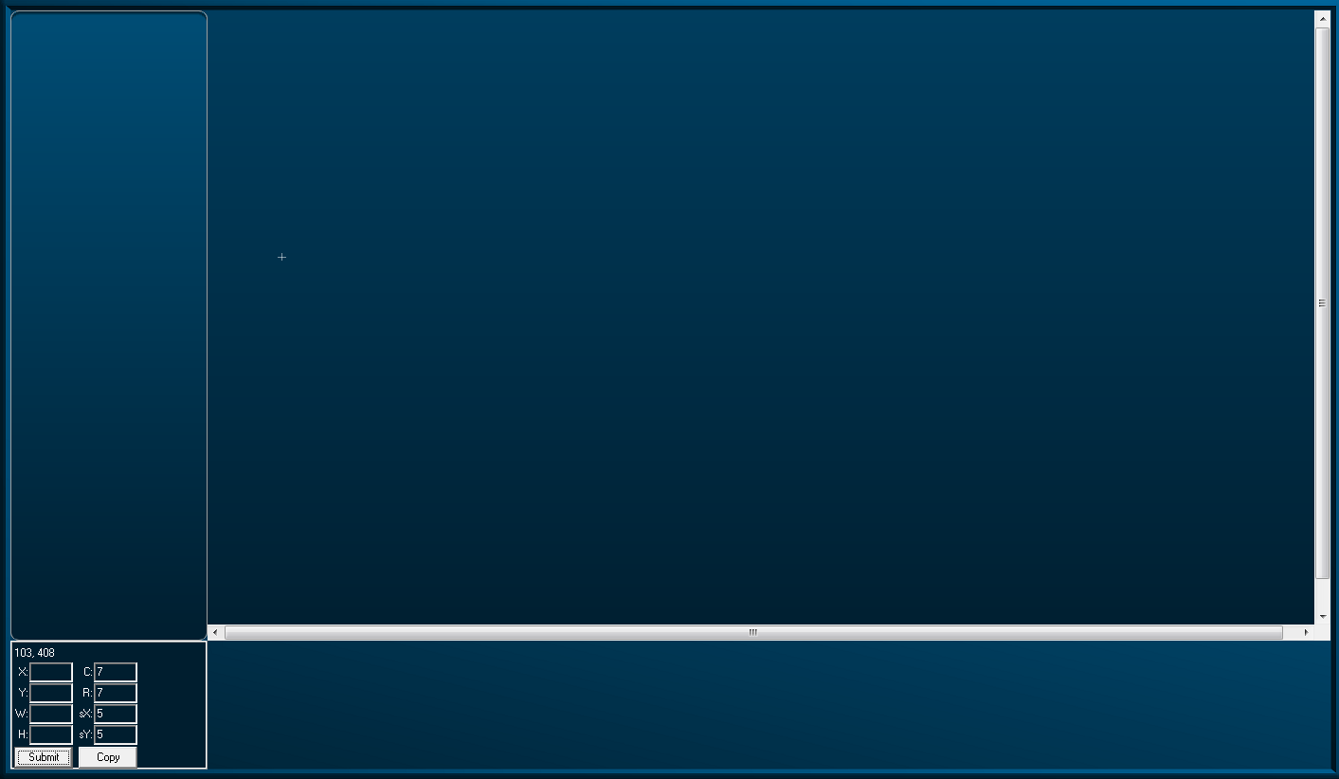

Figure 8‑14: Edit Mode Window

Right-clicking again will give you a window with all the options you have to build the mimic (see Figure 8‑15).

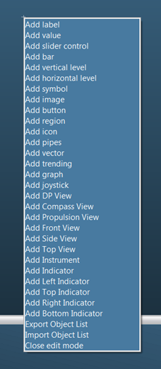

Figure 8‑15: Mimic Option Window

|  |  |
| --- | --- |
| **Option** | **Explanation** |
| Add Label | A Label is a text frame |
| Add Value | Any value that is given by a sensor |
| Add Slider Control | A slider to control settings to any output |
| Add Bar | A bar without index |
| Add Vertical Level | Vertical Level Bar |
| Add Horizontal Level | Horizontal Level Bar |
| Add Symbol | Choose a NavVision symbol |
| Add Image | Choose any image |
| Add Button | Button to trigger events |
| Add Region | Region to divide separate spaces |
| Add Icon | On/Off icon for indication |
| Add Pipes | Pipes to show ships piping system |
| Add Vector | Vector |
| Add Trending | Trending page (freely adjustable) |
| Add Graph | Graphic visualization of data |
| Add Joystick | Joystick for control |
| Add DP View | Dynamic view of ship for DP |
| Add Compass View | Show compass |
| Add Propulsion View | Propulsion |
| Add Front View | For DP |
| Add Side View | For DP |
| Add Top View | For DP |
| Add Instrument | Instrument for data sensors |
| Add Indicator | Small indicator mostly for engine data |
| Add Left Indicator | Variation on indicator |
| Add Top Indicator | Variation on indicator |
| Add Right Indicator | Variation on indicator |
| Add Bottom Indicator | Variation on indicator |
| Export Object List | Export tool for assigning mimic |
| Import Object List | Import tool for assigning mimic |
| Close Edit Mode | Close the editing mode |

Table 8‑3: Mimic options

 Not all options can be available due to license issues

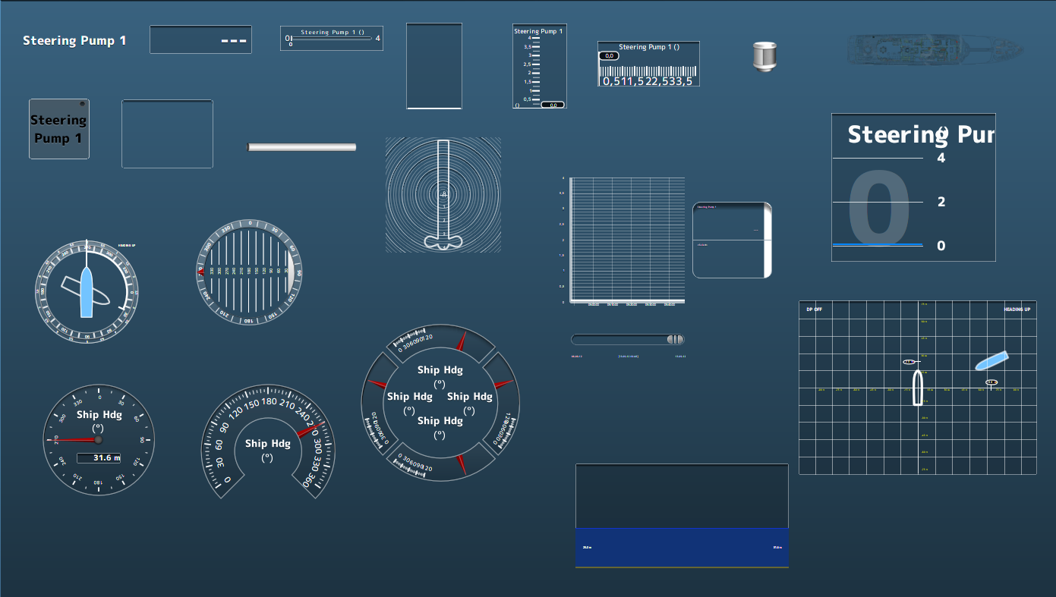

Figure 8‑16: example mimic options

It is beyond the scope of this document to elaborate too much on the mimics. For extensive explanation of working with mimics, please refer to the separate mimic manual. For general knowledge we will explain some basic features of standardization in mimics.

### Color usage

Platform statuses are preferably to be visualized to remote operators by using animation i.e. by changing the relevant symbol color and/or symbol shape an operator will be able to interpret statuses much easier rather than by *reading text* strings or by interpreting numbers. This section defines colors and shapes relevant for the majority of platform objects frequently being used on a ship’s platform.

### Colour coding

Mimics will use the following colour set for pipeline circuits and static (non-animated) symbols:

|  |  |  |  |  |
| --- | --- | --- | --- | --- |
| **Color** | **RGB** | | | **Medium description** |
|  | **RED** | **GRN** | **BLU** |  |
| **Brown** | 195 | 65 | 0 | Fuel oil |
| **Olive** | 128 | 128 | 0 | Lubrication oil |
| **Dark green** | 0 | 128 | 0 | Sea water, ballast water, fire main system |
| **Teal blue** | 0 | 128 | 128 | Low temperature fresh water (cooling water and potable water) |
| **Aqua blue** | 0 | 255 | 255 | High temperature fresh water (cooling water and potable water) |
| **Grey** | 128 | 128 | 128 | Bilge water, hydraulics, grey/black water |
| **Bright green** | 0 | 255 | 0 | Electrical distribution – Medium Voltage |
| **Orange** | 255 | 102 | 0 | Electrical distribution – High Voltage |
| **White** | 255 | 255 | 255 | Compressed air, ventilation air, exhaust gas |

Table 8‑4: Color markings of pipes

### Symbols

To learn about animated symbols you must be familiar with the basics of element processing first. Platform objects can be classified regarding their interface with the AM(C)S and functional behavior into so called, element types.   
In this way it is possible to distinguish between a sensor element type, valve element type, motor element type, etc. Once the platform objects are classified into element types the applicable mimic symbol for each platform object can also be specified since the element types identify the relevant monitoring and control abilities.

However mimics not only comprise of animated objects. For instance in case a platform object is not involved with alarm monitoring and control features at all then from the AM(C)S point of view it makes no sense to comprehend this object.   
Still these objects might be displayed in mimics as static (i.e. not animated) to improve clarity. The set of static symbols in NavVision is based on nowadays widely accepted icons being used in system diagrams and P&ID[2] drawings. Static symbols will be drawn in the color of the applicable medium.

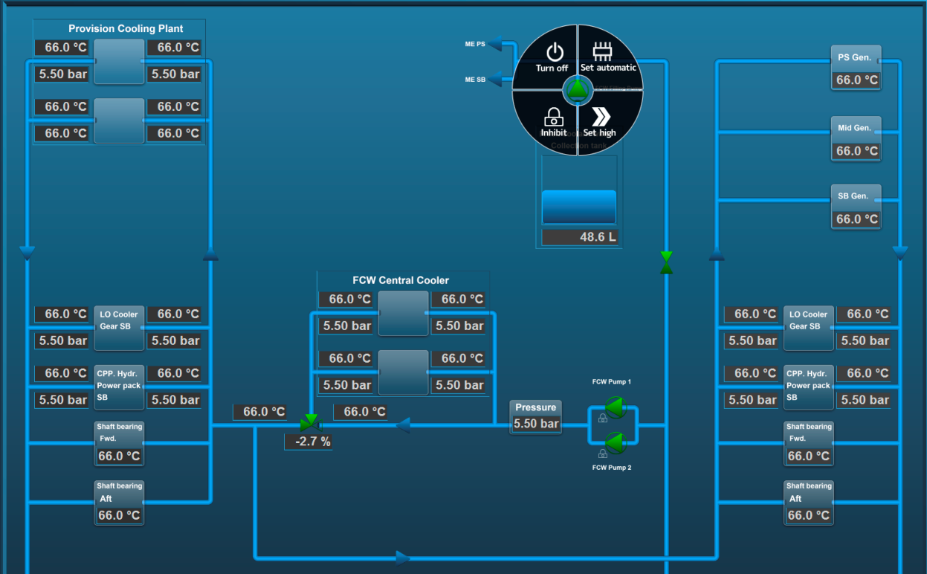

Figure 8‑17: Mimic layout

### Control elements

Control elements are used to interface a wide range of “Control” devices like pumps, fans, valves, generators, etc. via their relevant starter unit. Since these element types are suitable to process a wide range of components, several symbols are defined to represent each type.   
Colour animation is used to show the actual element status.

Chevrons, a single filled chevron (arrow) for low - and a double filled chevron (arrow) for high speed, show the difference between a control element running at high speed and a control element running at low speed. Chevrons without filling indicate an off condition.

|  |  |  |
| --- | --- | --- |
| **Status** | **Control element** | **Symbol** |
| Operable in two speeds, system off | Double chevron (no fill) |  |
| Operable in two speeds, system running at low speed | Double chevron (single chevron filled) |  |
| Operable in two speeds, system running at high speed | Double chevron (double chevron filled) |  |
| Operation is disabled (local control only or controlled by other OPC) | Padlock |  |
| Manual operation (controlled remotely) | Hand |  |
| Automatic operation (controlled by ACS[3]) | Chip |  |

Table 8‑5: Control element status

Table 8‑6: Colour codes (control elements)

|  |  |
| --- | --- |
| **Colour** | **Description** |
| **Grey** | Control element off (stopped), device is ok |
| **Green** | Control element on (running), device is ok |
| **Orange** | Control element in warning condition |
| **Purple** | Control element defective |
| **Red** | Control element in alarm condition |

Pump and generator control elements

|  |  |  |  |
| --- | --- | --- | --- |
| **Centrifugal pump** | **Piston pump** | **Generator** | **Status description** |
|  |  |  | OFF |
|  |  |  | ON (condition ok) |
|  |  |  | ON, WARNING condition |
|  |  |  | ON,  DEFECTIVE condition |
|  |  |  | ON,  CRITICAL condition |

Table 8‑7: Control elements and color animation

3- Way valve control element

|  |  |  |  |
| --- | --- | --- | --- |
| **3-way valve OFF** | **Status description** | **3-way valve ON** | **Status description** |
|  | 3-way valve OFF (status indication only) |  | 3-way valve ON (status indication only) |
|  | 3-way valve OFF, AUTO  (control by AMCS[4]) |  | 3-way valve ON, AUTO  (control by AMCS) |
|  | 3-way valve OFF, AUTO  (local control) |  | 3-way valve ON, AUTO  (local control) |
|  | 3-way valve OFF  (local control) |  | 3-way valve ON  (local control) |
|  | 3-way valve OFF, MANUAL  (controlled by AMCS) |  | 3-way valve ON, MANUAL  (controlled by AMCS) |
|  | 3-way valve OFF, MANUAL (local control) |  | 3-way valve ON, MANUAL (local control) |

Table 8‑8: Control elements with status indication

|  |  |
| --- | --- |
|  | Centrifugal pump ON,  Operable in two speeds, system off |
|  | Centrifugal pump ON,  Operable in two speeds, pump running at low speed |
|  | Centrifugal pump ON,  Operable in two speeds, pump running at high speed |

Table 8‑9: Control elements with speed indication

|  |  |  |
| --- | --- | --- |
|  |  | Fan OFF and ON |
|  |  | 2-way valve OFF and ON |
|  |  | Check valve OFF and ON |

Table 8‑10: Other control elements

## Functional description

### Measuring and control of Fresh Cooling Water (FCW) temperature

The description of the sequence below serves as a model for process measuring and control functions. The three-way valve regulates the temperature of the FCW automatically.

|  |  |  |
| --- | --- | --- |
| **Item description** | **Sensor type** | **Condition** |
| Three-way valve central cooler position indication | AI | Status |
| Three-way valve central cooler position control | A0 | Status |
| Three-way valve central cooler error signal | DI | Alarm |
| Three-way valve FCW inlet temperature | AI | Status |
| Three-way valve FCW outlet temperature | AI | Status |

Table 8‑11: I/O declaration (FCW temperature)

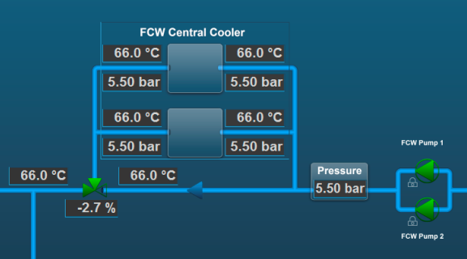

Figure 8‑18: Measuring and control of FCW temperature

### Alarm and monitoring of main engine exhaust gas system

The description of the sequence below serves as a model for alarm and monitoring functions with programmed calculation.  
By means of NiCrNi sensors the exhaust gas temperature of all cylinders will be measured.

Alarms are generated when certain cylinder temperatures are reached.

|  |  |  |
| --- | --- | --- |
| **Item description** | **Sensor type** | **Condition** |
| Engine temperature exhaust bank cylinder A1 | AI | Alarm |
| Engine temperature exhaust bank cylinder A2 | AI | Alarm |
| Engine temperature exhaust bank cylinder A3 | AI | Alarm |
| Engine temperature exhaust bank cylinder A4 | AI | Alarm |
| Engine temperature exhaust bank cylinder A5 | AI | Alarm |
| Engine temperature exhaust bank cylinder A6 | AI | Alarm |
| Engine temperature exhaust bank cylinder A7 | AI | Alarm |
| Engine temperature exhaust bank cylinder A8 | AI | Alarm |
| Engine temperature exhaust average value | Analogue | Alarm |

Table 8‑12: I/O declaration (engine exhaust gas system)

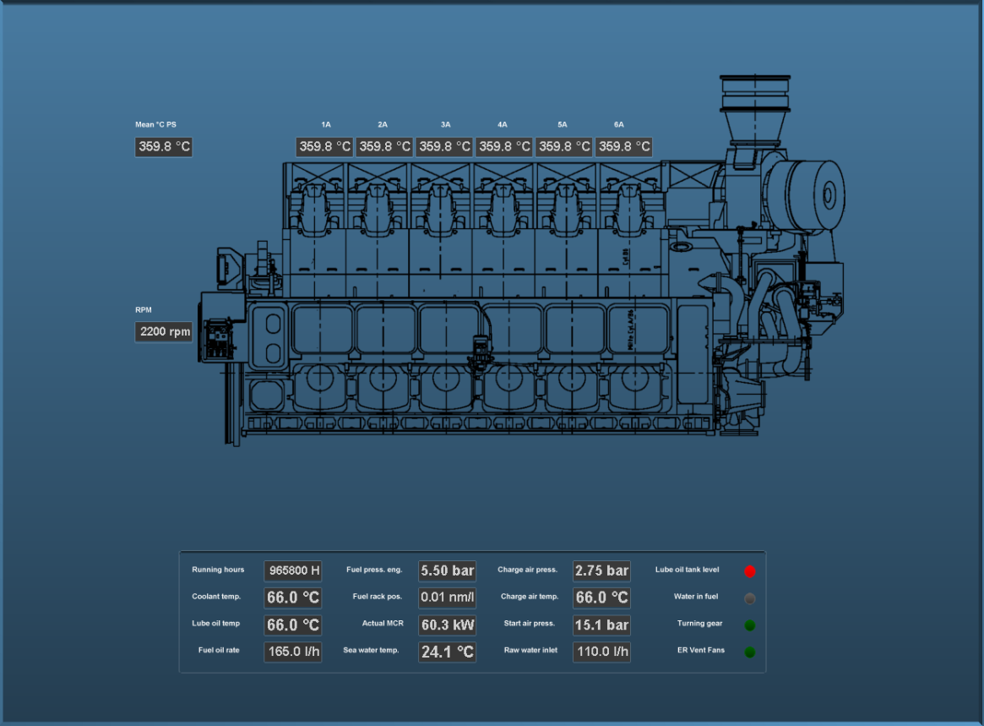

Figure 8‑19: Exhaust gas temperature measurement

 *For more examples see our “mimic example booklet”.*

# Duty alarm system

## Introduction

The duty alarm system provides machinery alarms to bridge, cabins and public areas for an unattended (unmanned) machinery space. The duty alarm system will be configured from a particular Operator Work Station (OWS).

Duty Alarm Panels (DAPs) at each location are connected with the automation system via the system network (network switch and local processing unit). They display the information for machinery alarms and settings such as alarm group status, operation status, and on-duty selection.

The duty alarm system provides for signaling of Engine Control Room (ECR) to the cabins and bridge by a Duty Alarm Panel (DAP) or on a Local Operator Panel (LOP).

An engineer on duty can be selected from the Operator Workstation (OWS). He will be warned when an essential alarm is present in the unmanned engine room. A watch safety timer on the workstation monitors the engineer working in the engine room.

When the engineer does not acknowledge within 30 minutes, the relevant engineers alarm is invoked, warning all engineers and bridge.

An engineer can be called on demand from the ECR on the OWS. Each station has its own caller identification.

: *For more detailed information on “manned” and “unmanned” systems we refer you to the appropriate manuals.*

The “On duty” selection, “Call”, “Unattended” and “Attended” functions are implemented on a dedicated mimic.

In general an alarm comes with visible and audible notifications.

The duty alarm system distinguishes two different alarm modes i.e.:

* Attended alarm mode
* Unattended alarm mode

## General

The duty alarm system is used for the transfer of alarms to the technical crew in case of an unattended machinery space. The duty alarm system will be configured from a particular Operator PC (OPC).   
The duty alarm system provides unambiguous audio visual annunciation of alarms and warnings via a dedicated banner located at the top of the alarm panel screen.

A watch and call system extends the central alarm system to engineers' cabins and public areas when machinery spaces/control rooms are unattended.

The duty alarm system distinguishes two different alarm modes i.e.:

* Attended (see section 9.3.4)
* Unattended (see section 9.3.5).

Alarms will be distributed to all Duty Alarm Panels (DAPs), servers and clients.

## Design principle

### Alarm groups

All alarms monitored values are divided into alarm groups. Alarms belong to a specific alarm group (see Figure 9‑1). Active alarms are indicated by a flashing light (unacknowledged alarm) or steady light (acknowledged alarm).

The alarm messages are displayed on top of the screen and can be scrolled by means of the

scroll buttons (see Figure 9‑2).



Figure 9‑1: Alarm groups



Figure 9‑2: Alarm scroll buttons

### Alarm types

#### Alarm detection for analogue signals

The following functions are included:

* Instrument failure alarms
* Low-low process alarms with or without action (slow-down)
* Low process alarms
* High process alarms
* High-high process alarms with or without action (slow-down)
* Return to normal detection with dead-band to avoid alarm fluctuations
* Adjustable filter factors to filter fluctuations in the incoming signals
* Time delay of alarm triggering and return to normal messages.

#### Alarm detection for on/off (two state) signals

The following functions are included:

* High process alarms
* Return to normal detection
* Time delay of alarm triggering and return to normal messages.

#### Alarm detection for on/off signals with line check

The following functions are included:

* High process alarms (open or closed)
* Line broken alarm
* Line short alarm
* Return to normal detection
* Time delay of alarm triggering and return to normal messages.

### Alarm inhibits

Some alarms are conditional and will be inhibited when a specific condition is present. This function is accomplished by defining a signal as an inhibit source for a specific alarm or a specific group of alarms. This will show in the Alarm page (see Figure 9‑3).

### Attended alarm mode

NavVision® will transfer the alarm to the activated location.

In case of an attended or manned machinery space this location will be the:

* Engine Control Room (ECR)
* Accommodations (e.g. mess room and public areas).

### Unattended alarm mode

In case the operator is not present at the OPC in-control, but making his round to one of the machinery spaces or doing routine maintenance. Within this period of time, alarms that are present are visible on selected Duty Alarm Panels (DAPs).

The “Unattended” mode can be activated on the workstation that has control over the sensor alarm group. Activation of the unattended machinery space mode can only be done when all alarms of “Unattended” sensor alarm groups are acknowledged.

NavVision® will direct the alarm to the activated location.

In case of an unattended or unmanned machinery space this will be:

* The engineer on-duty
* Engine Control Room (ECR)
* Accommodations (e.g. mess room and public areas).

When a sensor alarm group is unmanned in “Unattended” mode, new alarms are indicated on the DAP of the engineer. On the panels, the alarm sounding (horn/buzzer) can be silenced (only local), but the alarms still need to be acknowledged on the OPC within the relevant technical area.

If alarms are not acknowledged within a specific period of time on the OPC in-control, the “General Engineers Alarm” (GEA) is invoked, independent from the “Attended/Unattended” mode. Once the GEA goes off, the alarm will sound on all alarm stations

## How an alarm is displayed

|  |  |
| --- | --- |
| **Panel** | **Alarm displayed** |
| Duty Alarm Panel (DAP) | On main screen |
| Operator Work Station (OWC) | On taskbar  On alarm viewer  In logbook  On any mimic showing the field-in-alarm |

 *The alarm viewer on the OWS uses the same layout as the DAP, thus making it easier for an operator to understand and operate the screen.*

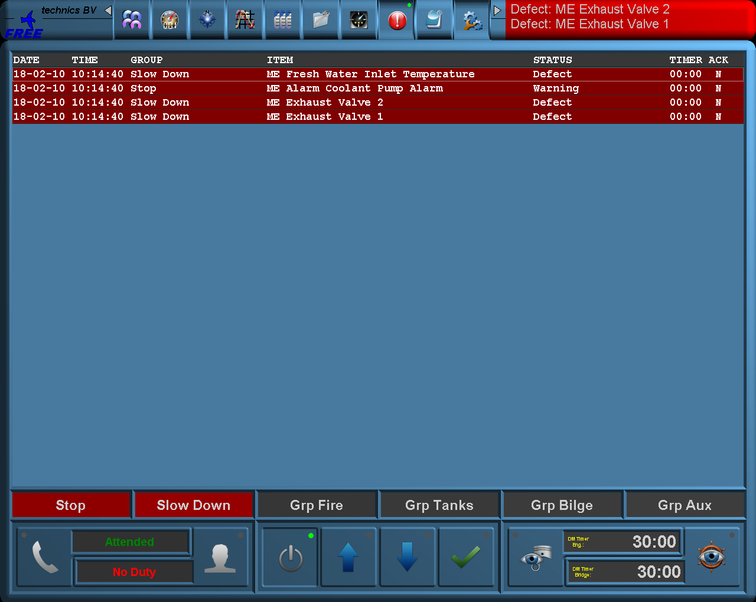

Figure 9‑3: Alarms on alarm viewer and taskbar

### How to acknowledge an alarm

The alarms must be acknowledged on the Operator PC (OPC) in the Engine Control Room (ECR) by means of:

* Double clicking the corresponding alarm line (alarm viewer)
* Double clicking the field (when red) in the MIMIC showing the field-in-alarm.

### When an alarm is not acknowledged within a specific period of time

The General Engineers Alarm will sound on all alarm stations, until it is accepted / acknowledged, in which case the alarm goes off.

Any unacknowledged alarm is always shown on top of the acknowledged alarms of the alarm viewer (incl. DAP) and will be flashing red.

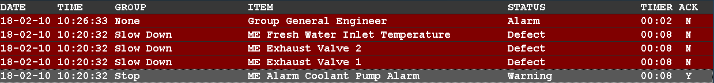

Figure 9‑4: One acknowledged and three unacknowledged alarms (incl. GEA)

### How to silence an alarm (not at ECR)

You can silence an alarm on all other locations.

This will silence the alarm buzzer for 3 minutes, but will not acknowledge the alarm.

The engineer is required to go to the Engine Control Room (ECR) to acknowledge the alarm.  
On other systems, silencing the alarm is also called an “audible acknowledge”. We will however use the term “silencing” throughout all of our documentation.

### When will an alarm disappear

An alarm will disappear only when rectified AND acknowledged. Acknowledged alarms will show in the normal instrument colour. (see Figure 9‑5).

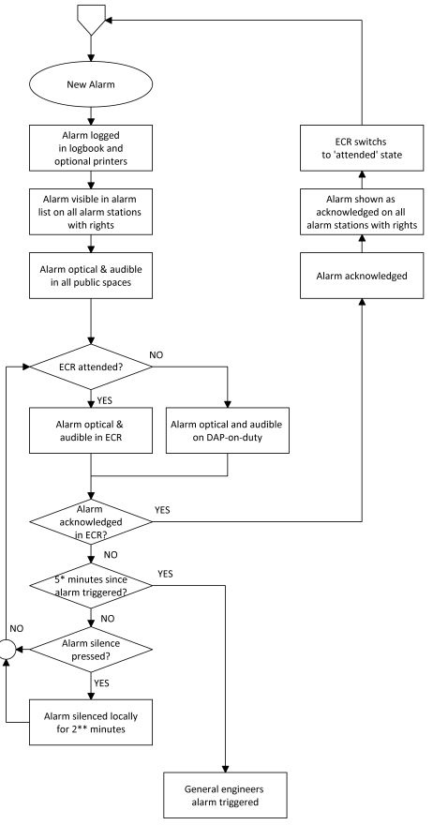

Figure 9‑5: typical alarm sequence

### Duty Alarm Panel (DAP)

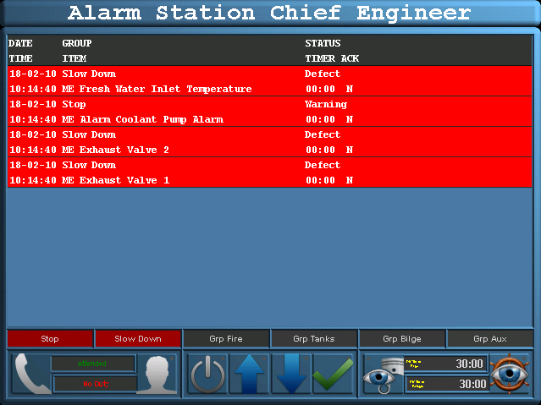

Figure 9‑6: Duty Alarm Panel (DAP)

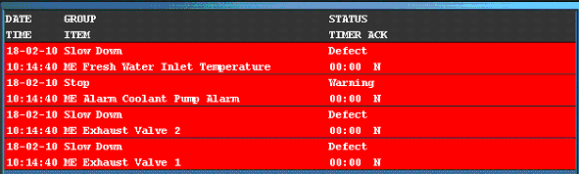

Figure 9‑7: Alarm and status area



Figure 9‑8: Alarm groups

### Controls and indications

The on-duty selection, call, attended and unattended functions are implemented on a dedicated mimic. The on-duty mimic can be called up by selecting one of the two buttons at the bottom of the screen

* Call button
* On-duty indication
* Duty select button.



Figure 9‑9: Call button / on-duty indication / duty select button

#### Call button

From the duty alarm panel it is possible to call for a specific area (e.g. bridge or engine room), engineer or all engineers.

Press the “Call button” (see Figure 9‑9), the call indicator will lit, and the selected area or engineer is called.

To cancel the call, push the “Call button” again.

#### On-duty indication

Press the “ATTENDED” button to signal that the engine control room is manned.

Press the “UNATTENDED” button to signal that the engine room is unmanned.

Via the “Duty select button” (see Figure 9‑9) the responsible engineer (on-duty engineer) can be selected and will be displayed on the display (“On-duty indication”).

#### Duty select button

Push the “Duty select button” (see Figure 9‑9) and select the responsible engineer. The “On-duty indication” displays the responsible engineer.

#### Panel active button

The switch-on or switch-off the duty alarm panel. When duty is selected it is automatically turned on. Other stations can chose if they want to hear the alarms by switching their station on or off.



Figure 9‑10: Panel active button

#### On-duty selection

The on-duty mimic contains duty selection and call buttons. In addition, the selection attended/unattended can be made.

The “Bridge watch safety timer”, “Engine room watch safety timer” (see Figure 9‑11) including the “Engine room watch active button” and “Bridge watch active button” are also implemented on the server (dead man’s watch).

At the bottom of the screen, the state of the watch safety timer is displayed:

* When the engine room is UNATTENDED, the engine room watch safety timer is “OFF”   
  When the engine room is ATTENDED, the engine room watch safety timer is “ON” (remaining time is counting down).

#### Watch safety timer

The watch safety timer (DM Timer[5]) remaining time is displayed at the bottom of each screen on the workstation. The timer counts down from 30 minutes back to 0 minutes.

When the timer reset has not taken place and the 3 minutes pre-alarm limit is reached, an alarm occurs on the workstation that no “Reset” button has been selected within the last 27 minutes.

The watch safety timer “Remaining time” indication (see Figure 9‑12) displays now in a red.

When selecting the “General Engineers Alarm” (GEA) button, or after countdown to 0 minutes (3 minutes warning cycle has passed) this means that the “Reset” button has not been selected within the last 30 minutes and the GEA is invoked.

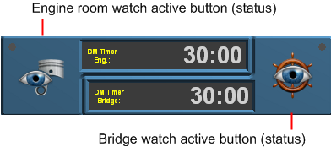

Figure 9‑11: Watch safety timer

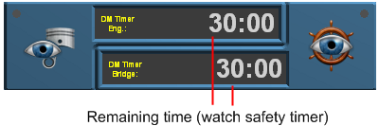

Figure 9‑12: Watch safety timer (remaining time indication)



Figure 9‑13: Bridge watch

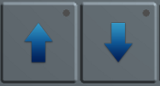

Figure 9‑14: Operating buttons

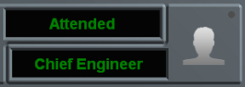

Figure 9‑15: On duty indication

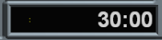

Figure 9‑16: Bridge watch safety timer

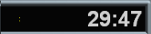

Figure 9‑17: Engine room watch safety timer

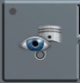

Figure 9‑18: Engine room watch button

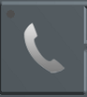

Figure 9‑19: Call button



Figure 9‑20: Acknowledge button

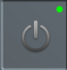

Figure 9‑21: Panel active button

## Duty Alarm Panel functionalities

|  |  |
| --- | --- |
| **Functionality** | **Description** |
| Alarm & status area  (see Figure 9‑7) | In the “Alarm & status area” the alarm summary, alarm history and tag details will be presented. The alarm summary will present the active alarms with time stamps and values.  The alarm history will present the alarms with time stamp of the alarm occurrence, acknowledge and gone date and time. |
| Operating buttons  (see Figure 9‑14) | The “Operating buttons” (arrow up & down) are used for scrolling through the alarm page(s). While pressing the “Enter” button an alarm history, tag details and alarm summary menu is shown. |
| On duty indication  (see Figure 9‑15) | The “On duty indication” indicates which engineer is on duty. The panel that is in the operational mode “On duty” the Field “On duty” will light up. In addition, the field that defines the engineer will illuminate (1st, 2nd, 3rd etc). The panels that are not on duty will indicate the engineer on watch. |
| Alarm groups  (see Figure 9‑8) | The “Alarm groups” button indicates if an alarm is active within a critical group. |
| Failure indication  (see Figure 10‑2) | In case of a failure (network) an audible alert (buzzer) is triggered. The text “Connecting” appears on the display to indicate the lack of connectivity. The alert can be silenced by touching the display screen. |
| Bridge watch safety timer[6]  (see Figure 9‑17) | In case of a one man bridge, the bridge watch alarm can be enabled for safety purposes. The bridge watch safety timer must be reset within a specific amount of time (using the reset button of an alarm panel on the bridge), else a General Engineers’ Alarm (GEA) is invoked on all stations. |
| Engine room watch alarm  (see Figure 9‑18) | The Duty Alarm Panel indicates whether the machinery space is “Attended” or “Unattended”. |

Table 9‑1: Duty Alarm Panel functionalities

## On duty select procedure

An engineer on duty can be selected on duty from the allocation control button on the Duty Alarm Panel (DAP). The engineer will be warned when an alarm is present in one of the “Unmanned” alarm groups. Using the alarm panel of the engineer on duty, the engineer is notified of new alarms. This is done by warning light, buzzer and/or on-screen functions. Alarms are always represented on the screen.

The duty alarm system sends alarms to the responsible persons in case of incorrect situations whenever the machinery spaces are unattended. The release procedure for duty alarms will be done (before leaving the area) at the main Operator PC (OPC) in the Engine Control Room (ECR).

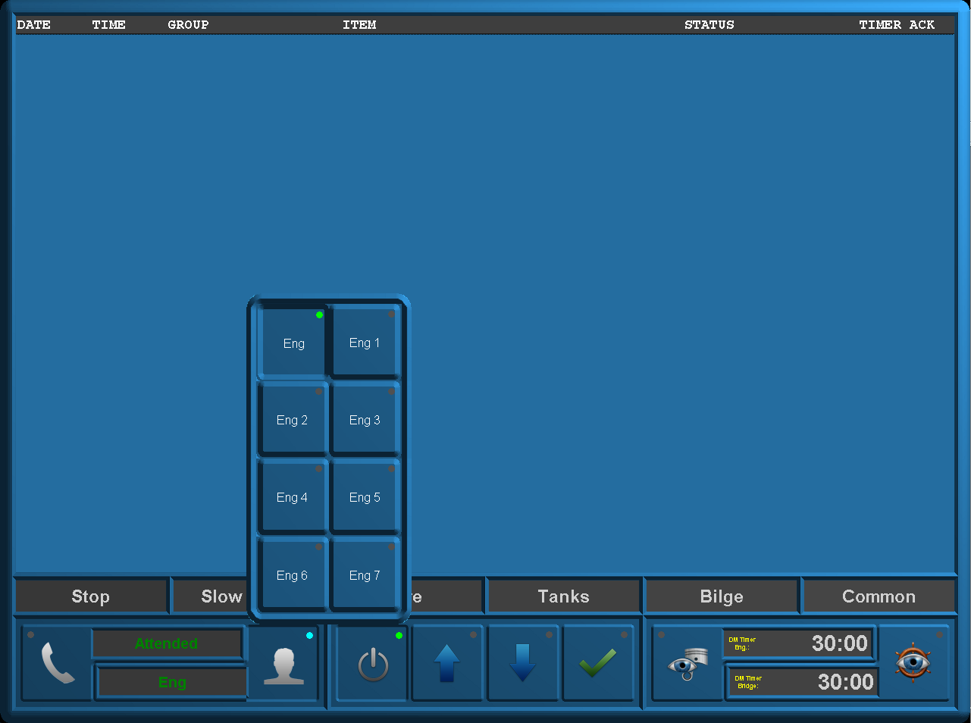

Figure 9‑22 Duty Alarm Panel (on duty select)

## Alarm acknowledge procedure

If during watch free operation an alarm occurs the normal procedure will be that the engineer on duty will receive an optical and acoustic alarm in his cabin. Accordingly he must Silence the alarm on his panel.

The alarm itself is still in the status not acknowledged. The engineer on duty must go to the ECR, to acknowledge the alarm and solve the problem in the control room.

When the engineer on duty ignores the alarm in his cabin, a repeat alarm function will be activated. This means, after a specific period of time the duty alarm system generates a General Engineer’s Alarm (GEA) on all stations.

## Call function

From the Duty Alarm Panel (DAP) it is possible to call for a specific engineer, bridge or all engineers (see Figure 9‑23).

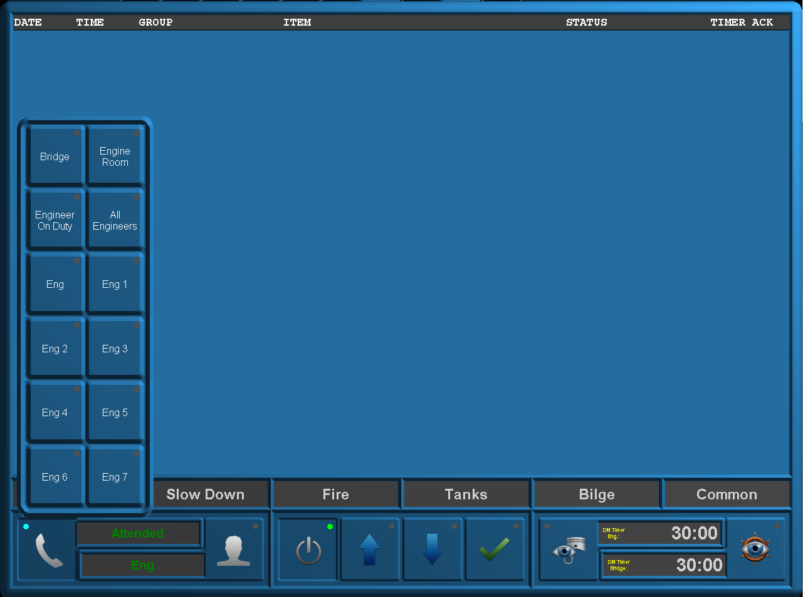

Figure 9‑23 Duty Alarm Panel (call function)

# Personnel alarm

## General

A personnel alarm provides a safety timer (see Figure 9‑18 and Figure 9‑23) for personal protection, used when a single person works in an unattended area. The personnel alarm consists of:

* A release station
* Acknowledge stations

### Release station

The release station is used to indicate whether a machinery space is “Attended” or  
“Unattended” and is preferably situated at the entrance of the machinery space. The release station consists of the following buttons i.e.:

* A “attended/unattended” push button
* A timer “active/inactive” button
* A alarm “active/silence” push button

|  |  |
| --- | --- |
| **Button** | **Detail** |
| Attended | Press when entering the machinery space to activate and when leaving to deactivate. |
| Timer | The safety timer can be deactivated (disabled) by using the workstation in the machinery space in conjunction with the right Password (see Figure 10‑1) |
| Alarm | Shows when the station is in alarm. Can be pressed to silence the alarm, which inheritably will reset the Timer. |

Table 10‑1: Release station buttons

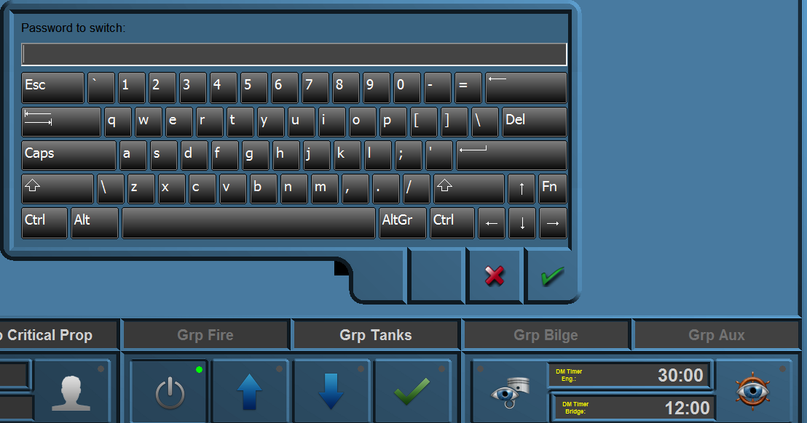

Figure 10‑1: Deadman Switch Password

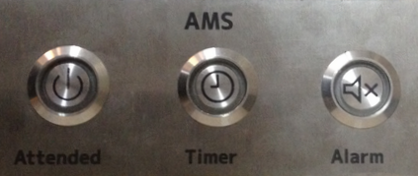

Figure 10‑2: Release station

### Alarm Panel

In order to acknowledge alarms to persons on duty an Alarm Panel is used (this panel can also be used in public spaces and on the bridge).   
The Alarm Panel consists of three buttons, the “Dim” button, the “Timer Button” and the “Alarm Button”. These buttons have a combined function i.e. button and lamp (see Figure 10‑3).

|  |  |
| --- | --- |
| **Button** | **Detail** |
| Dim | cycle through diverse states of brightness for all the LED’s |
| Timer | shows if the Deadman Timer is activated and has no push-function |
| Alarm | Shows with the LED if there is an active alarm. By pressing the button you can silence the panel’s buzzer for three minutes. |

Table 10‑2: Alarm Panel

The Alarm Panel consists of hardwired buttons with LED[7] lighting.

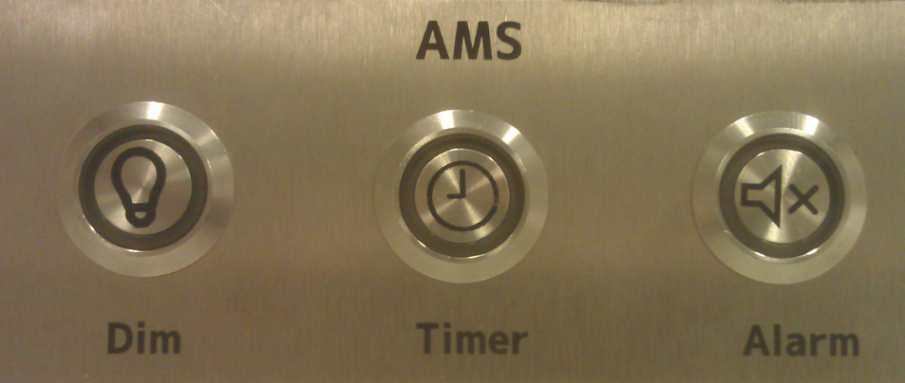

Figure 10‑3: Alarm Panel

### BNWAS

The BNWAS (Bridge Navigational Watch Alarm System) is also a personal safety system but then mend to be used on the bridge. You can use it the same way as the entrance module (see Figure 9‑13 and Figure 10‑1). The BNWAS panel (see Figure 10‑4) consists of the following buttons:

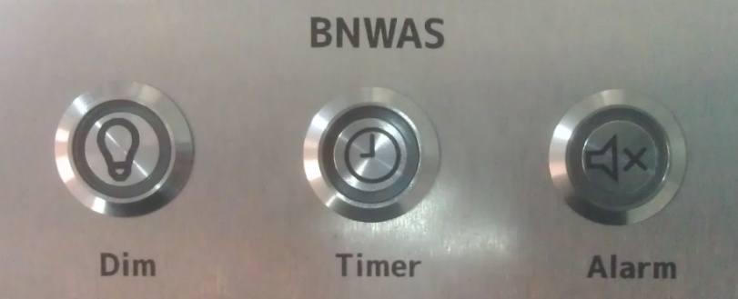

Figure 10‑4: BNWAS Panel

|  |  |
| --- | --- |
| **Button** | **Detail** |
| Dim | cycle through diverse states of brightness for all the LED’s |
| Timer | shows if the Deadman Timer is activated and has no push-function |
| Alarm | Shows with the LED if there is an active alarm. By pressing the button you can silence the panel’s buzzer for three minutes. |

Table 10‑3: BNWAS

## Alarm monitoring and control process

|  |  |
| --- | --- |
| **Step** | **Detail** |
| 1 | The Alarm, Monitoring and Control System (AMCS) detects when a person enters a machinery space via the switch on the “Release station” in or near the machinery space. |
| 2 | After 27 minutes an audible or visual alarm will be initiated by the system in the appropriate machinery space to prompt the engineer to reset the safety timer. |
| 3 | During each period of 30 minutes the person working alone in that space must reset the safety timer to confirm his presence/well-being. A “Reset” command must be given via the reset button on the “Timer reset station”, the workstation or on one of the mushroom buttons in that particular machinery space.  Each space has its own safety timer. |
| 4 | If the “Reset button” is still not pressed within 3 minutes after the warning, a general alarm will sound on all the workstations. |

Table 10‑4: Alarm monitoring and control process engineer

|  |  |
| --- | --- |
| **Step** | **Detail** |
| 1 | The Alarm, Monitoring and Control System (AMCS) detects when a person is on watch in the wheelhouse via the switch on the “Release station”. |
| 2 | After 12 minutes an audible or visual alarm will be initiated by the system in the Wheelhouse to prompt the officer to reset the safety timer. |
| 3 | During each period of 12 minutes the person working alone in that space must reset the safety timer to confirm his presence/well-being. A “Reset” command must be given via the reset button on the “Timer reset station”, or at the workstation. |
| 4 | If the “Reset button” is still not pressed within 3 minutes after the warning, a general alarm will sound on all the workstations. |

Table 10‑5: Alarm monitoring and control process BNWAS

# Setting and adjustment

## Users

Upper tab “Users” includes all settings for different access levels for different users.

Main reason for user access control is protecting the system. Limiting users changing the configuration settings etc. limits the chance system operation of NavVision is disrupted.

Three user types are available. Administrator is the user type for Free Technics and its representatives. Login as Administrator releases all rights. This is logical because during installation and commissioning you need access to all NavVision settings.

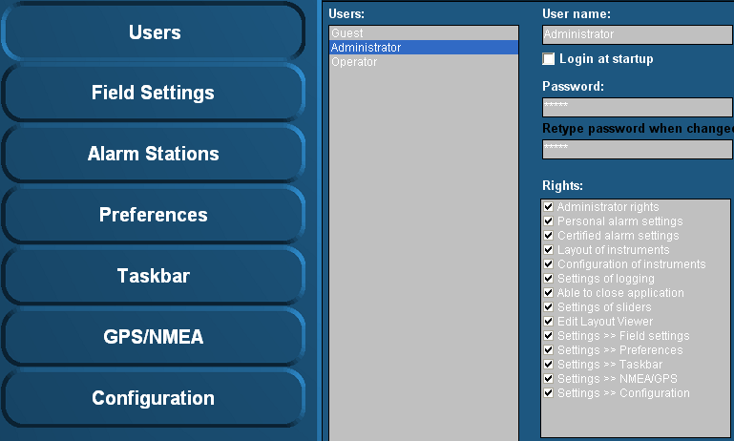

Figure 11‑1: Users

### User name

This box shows the active user and his rights.

### Login at startup

Tick this box to set the default user at startup (default operator).

### Password

 *User “Administrator” is always password protected.*

If a password is required please type password here. When changing the password or typing the password for the first time, retype password in box “Retype password when changed”.

### Rights

Rights are divided into groups and can be granted (by check mark) to each user.

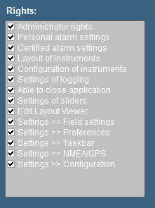

Figure 11‑2: Rights

|  |  |
| --- | --- |
| **Rights** | **Effect of rights** |
| Administrator rights | Full access to the system's configuration parameters |
| Personal alarm settings | Settings on the particular DAP[8], for this user only |
| Certified alarm settings | Configuration of global alarm stations |
| Layout of instruments | Edit instrument's display mode (digital, analogue, graphic) |
| Configuration of instruments | Change instrument's assigned field |
| Settings of logging | Enable/disable logging of fields |
| Settings of sliders | Changing the value of sliders |
| Edit layout viewer | Right to edit a mimic of the Layout Group viewer |
| Able to close startup viewer | Right to close all mimics (go to NavVision background) |
| Able to close application | Right to shut down NavVision |
| Settings → Field settings | Access to the Field Settings page in the Tools viewer |
| Settings → Preferences | Access to the Preferences page in the Tools viewer |
| Settings → Taskbar | Access to the Taskbar page in the Tools viewer & configuration of the selectable & default viewers |
| Settings → NMEA/GPS | Access to GPS/NMEA settings page in the Tools viewer |
| Settings → Configuration | Access to the Configuration page in the Tools viewer |

* **Administrator rights**All rights.
* **Operator rights**  
  Via “Setting > Preferences”, you are allowed to change time and language, ships heading reference and SMS service.   
  This can be extended with additional rights depending on what is needed.

 *Under “Operator rights” you will NEVER get the rights as mentioned below.*

* Administrator rights
* Certified alarm setting
* Configuration of instruments
* Settings of logging
* Settings of sliders
* Edit layout viewer
* Settings > Field settings
* Settings > Configuration

### Add / Remove

Via the “Add / Remove” buttons a user can be added or removed.

For example you need to add a user for the shipyard or the installation company. Click “Add” and fill in a new user name. For the removal of a user, click the user then click “Remove” and acknowledge.

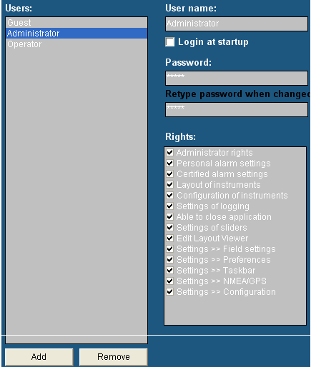

 *Setup the new user direct at the beginning of the setup. In this way the user will get access to all settings and adjustments. If you set a new user after you’ve finished installing and adjusting the system, this will result in an empty user.   
All adjustments you’ve made are not visible. You can get the adjustments you made to appear in the new user by copying the content of the “administrator.ini” to the new user ini-file (i.e. shipyard.ini). For more information please refer to section “Adjusting ini-files”.*

Figure 11‑3: Add / Remove

1 Due to improvements and changes, this article will become obsolete. It will be removed as soon as the new changes take effect.

## Field settings

Under “Tools > Field Settings” you’ll find the tools to adjust and fine-tune on field label basis. For every I/O you attach a label onto you will find different ways of tuning in each tab of field settings.

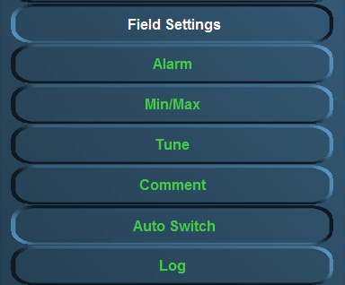

Figure 11‑4: Field settings

The following settings are available:

* **Alarm**  
  Settings of user alarms, warning alarms, critical alarms, Alarm group settings, SMS settings, inhibit settings
* **Min/Max**  
  Setting of instrument range, zone marking, default unit and filter
* **Tune**  
  Setting of tuning table, see results and sender
* **Comment**  
  Check and change group label, group label logbook, field label and field label instrument
* **Auto Switch**

Make various in-and outputs react on each other.

* **Log**  
  Setting and enabling/disabling logging for each field label.

### Alarm

Choose the field you would like to change the alarm settings for (e.g. “Steering and Propulsion >Rudder > Angle”).   
Depending on the field selection, a number of field settings are available. In this example the following settings are allowed:

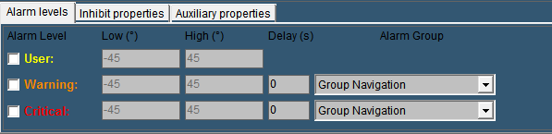

Figure 11‑5: Alarm settings

An alarm field as this “rudder alarm” is not set as alarm by default. It gives an analogue value )in this case within the range -45 degree and +45 degree. Now within this range you can set a few alarms. The settings that can be altered are the following:

#### Alarm levels

* + **User**Via this check box the user alarm settings are set. In this example you can set the alarm threshold (low and high). Usually you will not set them here but in the instrument itself (it is a user alarm) but you can check and/or change them here
  + **Warning**   
    The warning alarm is a dedicated alarm to warn the user when certain thresholds are exceeded. This alarm can have a dedicated delay and a dedicated alarm group (i.e a high or low alarm).   
    Choose these thresholds widely within the boundaries of the capabilities of the attached device (check specific manual for the values)
  + **Critical**To set the critical alarm thresholds (i.e. too high or too low) (check specific manual for these values).
* **Delay(s)**The time (in seconds) the system will wait before it will show the specific alarm that is triggered. This is necessary if a hysteresis is needed (i.e. a bilge alarm that is on the edge of the alarm by the rocking of the ship, will not go of all the time if you put in a delay)
* **Alarm Group**Here you can put the alarm in a specific group. By putting it in a group you can manage the rights of different users on whether they can silence or acknowledge these alarms. For more detailed information please refer to section “Alarm stations”.

By example it will look like this (Figure 11‑6).

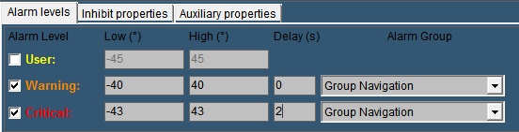

Figure 11‑6: Alarm example

The next tab is for the inhibit properties.

#### Inhibit Properties

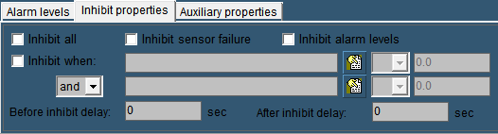

Figure 11‑7: Inhibit Properties

There will be certain occasions where you do not want the alarm to go off. For example an oil pressure alarm from an engine will normally also be in alarm when the engine is shut down. This is not wanted as an alarm. Or when a sensor is broken and there is no time to repair it for a while, it will be easier to inhibit the “Defect Alarm” of this sensor until you have time to repair it.

* **Inhibit All:**

This checkbox is used to inhibit all the alarms from this particular sensor. Especially when the sensor is defect, it will come in handy. In the alarmpage (See Alarmpage) you will constantly see that the sensor is inhibited, so you won’t forget.

* **Inhibit Sensor Failure**Some sensors (i.e. 4-20 mA) tends to go a little bit out of range. Normally this will be no problem. However if a 4-20 mA sensor drops below 4 mA or goes higher than 20 mA, NavVision® will see this as a sensor failure and will give an alarm. If you think it is just the range of the sensor that is giving the problem, you can check this box to stop these alarms.
* **Inhibit Alarm Levels**If you have set alarm levels as mentioned in “Alarm Levels” And you need them out for a while, check this box.
* **Inhibit When**

In the earlier mentioned oil pressure alarm, you don’t want that alarm to go off when the engine is not running. This is where “Inhibit When” will help. In the inhibit properties of that particular sensor you mark the checkbox. Now you search the belonging engine running field in the box next to that, by clicking the tab besides that. While you want the alarm to be inhibited when the engine is not running, in the next field you choose “<” from the dropdown menu. Finally you set an amount (in this case 0.5) in the adjacent field. Now, when the engine is not running, the alarm will not sound. (see Figure 11‑8). Finally you can choose an additional field (And/Or) to specify even further. For example you can use the Shaft Speed RPM as backup. (see Figure 11‑9).

“Before Inhibit Delay” and “After Inhibit Delay” are delays to catch up for irregularities in the sensors behavior.

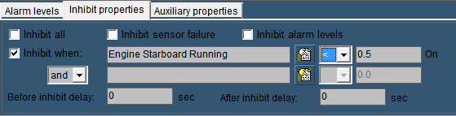

Figure 11‑8: Inhibit When

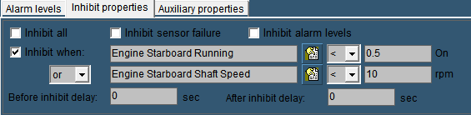

Figure 11‑9: Inhibit When 2

 *If you specify just one inhibit field, make sure the “and/or” box is set to “and”. Otherwise the alarm field will not work.*

#### Auxiliary Properties

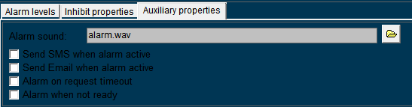

Figure 11‑10: Inhibit when 3

* **Alarm Sound:**Obsolete
* **Send SMS When Alarm Active**If you have the SMS Alert License you can tick this checkbox to send a text message to your phone, every time the alarm is triggered.
* **Send Email when alarm active**

If you have the Email license and connection to the internet, you can get an email for this field in your inbox

* **Alarm On Request Timeout**Especially valves will have a long time to open or close. You can set a timeout on the time to get an alarm if the conditions aren’t met in the given time.
* **Alarm When Not Ready**

If the sensor is equipped whit an output to state that it is not ready, tick this checkbox to get an alarm.

### Min/Max

Under “Tools > Field Settings > Min/Max” (see Figure 11‑11) the instrument boundaries can be set. For example the “Engine 1 Oil Pressure” instrument can be set as follows:

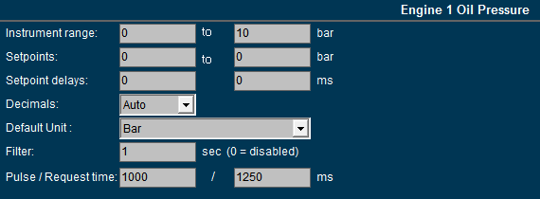

Figure 11‑11: Min/Max settings

#### Instrument range

The instrument range field is used to define the measuring range (scale) of the instrument.   
For example: the indicator below is scaled from 0 to 30 bar.

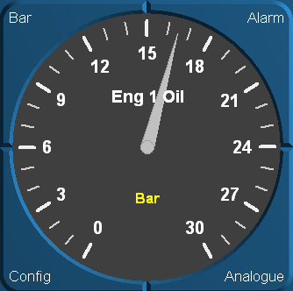

Figure 11‑12: Engine 1 oil pressure indicator (0 - 30 bar)

*:*

*In order to detect and identify a deviating function, make sure that all instrument (in a column or row) pointers are aligned to the same position (default mode).  
Check the default values of each instrument and set the instrument range accordingly.*

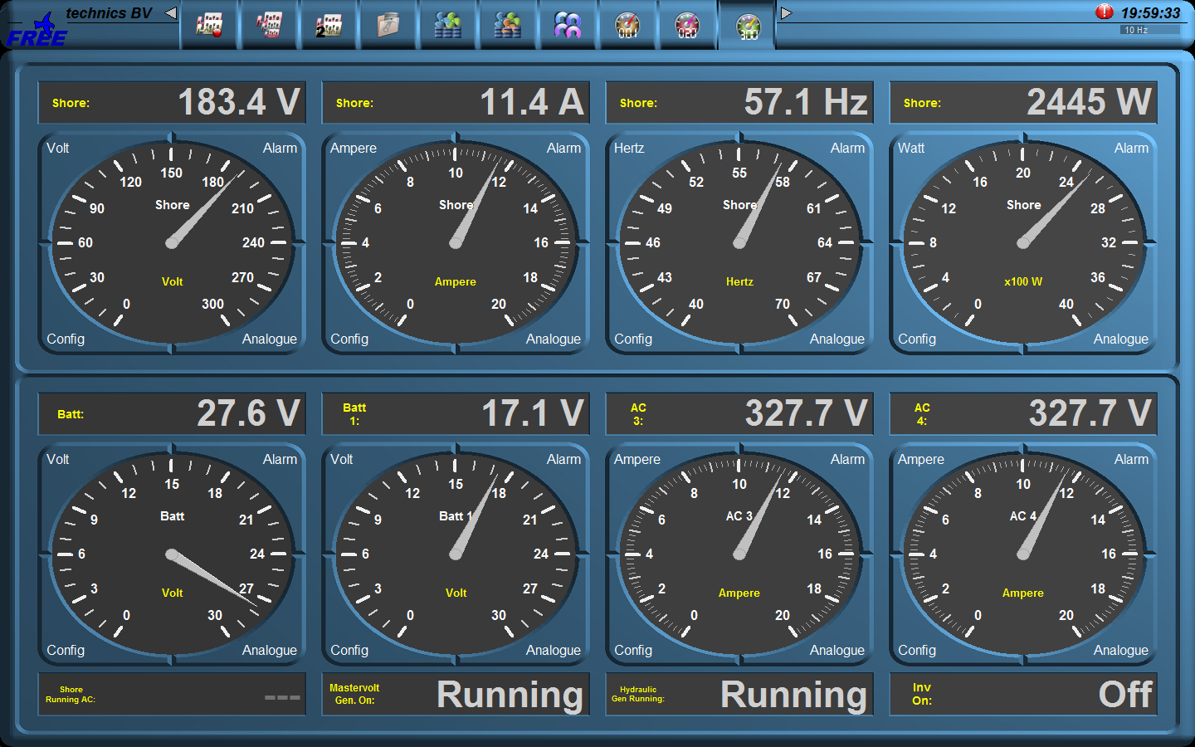

Figure 11‑13: Instrument pointers

By aligning the instrument pointers to the same position (see Figure 11‑13) it will be easier to detect a deviating function.

#### Setpoints

If the sensor values and their working ranges are known, you can set a zone marking. It puts a grid over the desired values on the instrument, to verify if the readings are correct.

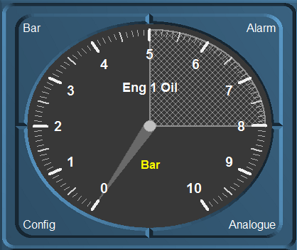

Figure 11‑14: Zone marking

*: For now this is only working in regular instruments. It will be implemented later for mimic instruments.*

#### Setpoint delay

Whit the delay you can set a time in milliseconds before an alarm will be triggered. This prevents recurring alarms if the sensor is working on the edge of the setpoint

#### Decimals

To make sure that in a mimic all the decimals in a value are of the same length, you can choose the number of decimals here. This will make it easier to get the same decimals for different values as FT NavVision© will calculate its own decimals. Standard is “Auto”.

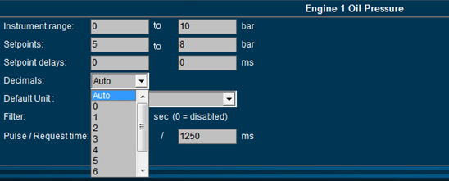

Figure 11‑15: Decimals

#### Default unit

At startup each instrument will show the unity in which it will display the data. Depending on the sensor type select the desired unity (see Figure 11‑16).

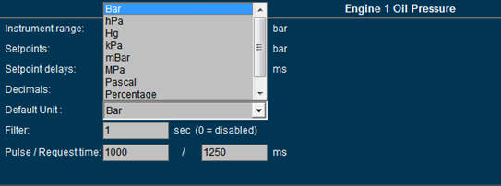

Figure 11‑16: Default unit

*: in a mimic you can choose a secondary value to show in the mimic itself. See chapter about mimics*.

#### Filter

If an instrument reading seems to be a little erratic, you can select a higher number (see Figure 11‑16) to dampen the movement of the instrument pointer.

#### Pulse/Request time

The pulse time is the time a pulse will last after pressing the button in milliseconds. If you need a longer pulse (i.e. for starting or stopping a generator) you can change it here.

The request time is how long a request stays active. For example: some valves will take up to 30 seconds to open or close. If the time is set to 1250 ms and the valve didn’t get a feedback that it was opened or closed, it will stop or give an alarm. If you increase the amount of time here, FT NavVision© will wait for that longer time to give an alarm.

This also goes for requests that are send over Modbus etc. sometimes you need to let it wait for a longer time.

### Tune

#### Tune table

The “Tune table” settings allows the user to fine-tune the output of a sender.  
 **Example 1: Sensor value too low.**  
In such a case you must change the second input value. You can change the input value as follows:Input value= 0.8 → Real value = 1.  
The statement above implies that for every input of 0.8 bar the output (actual reading) is 1 bar. In other words, any sensor input value of 4 bar corresponds with an instrument reading of 5 bar.   
  
**Example 2: Sensor value too high.**Change the input value as follows:  
Input value = 1.2 → Real value = 1.  
The statement above implies that for every input of 1.2 bar the output (actual reading) is 1 bar. In other words, any sensor input value of 5 bar corresponds with an instrument reading of around 4 bar.   
For threshold values you can change the first input value. If the pressure indication has to start later than given, you can put in “Input value = 0.2 → Real value = 0”   
This will make the instrument starts displaying as soon as the threshold of 0.2 bar has been reached. This can be accomplished the other way around.

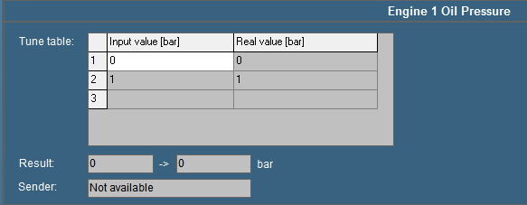

Figure 11‑17: Tune table

#### Result

The “Result” box displays the exact incoming measuring data. The second box displays this data via the respective instrument that is connected to the sensor.   
If for example the sensor gives a pressure (bar) output for every 20 mV, the real time result may read “100 → 5 bar” (see Figure 11‑17). As a result the sensor reads “100 mV” and indicated as “5 bar” on the instrument.

*:*

*Values may differ per sensor type.*

#### Sender

The “Sender” box (see Figure 11‑18) displays the device name where the data is coming from. If the sender field shows “Not available” indicates that that the sensor isn’t giving any data (for a reason why it is not giving data, check the troubleshooting section).   
Other items you can see in the box “sender” are: NMEA, Wago, Serial, Modbus, Calculated in, etc. this gives you an indication where the signal is coming from.

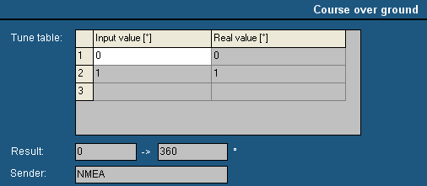

Figure 11‑18: Sender box

### Comment

In the “Comment” section you can change the names of different fields to get an overall clarity. These names can be changed for the clarity in an instrument or a logbook if the sensor has an explicit name. Sometimes you have to use an auxiliary field when the name for that sensor is not available.

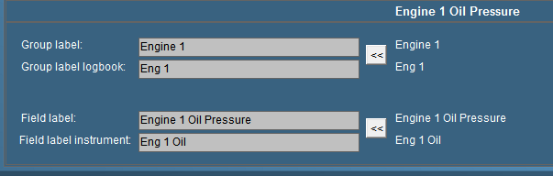

Figure 11‑19: Comment

#### Group label

Via “Group label” you can assigns a field to a specific “Alarm” group. The name is written in full so there will be no misunderstanding. It is especially handy if you have different sensors, which are arranged in different groups. Once grouped, you change them in “Group label”. For more detailed information concerning alarm groups please refer to section “Alarm stations”.

#### Group label logbook

A group label logbook is the abbreviation of the corresponding group label. The abbreviated group label is shown in column “GROUP” in the logbook (see section logbook) and the extensive alarm viewer.

#### Field label

A field label is the unique name of a sensor, pump, valve, etc... For every platform object that is connected to the AM(C)S a unique field label must be specified in NavVision®. NavVision contains an extensive list of default field labels and when a new field label is needed because an extra platform object is to be connected to the AM(C)S one of the unused default field labels must be selected. After selecting an unused label it should be renamed into the text you like (watch maximum number of characters), the renamed field label represents from then on the new platform object. In NavVision you can connect this field label to a mimic object, use it as a variable for calculations, connect it to a Wago I/O module, etc…

You see the representation of field labels in the Wago viewer (see section Wago), the extensive alarm viewer (column “ITEM”), the logbook (column “MESSAGE”), etc…

#### Field label instrument

The name of the sensor showed in the instrument is set in the field label instrument. While there isn’t always that much space in an instrument, we use an abbreviation of the “Field label”. If you have to make up a name yourself be sure to choose a name that is representing the sensor and is clear, even in the abbreviation.

### Auto Switch

#### General

Under auto switch you can automate some of the actions of I/O in a decent easy manner, without knowledge of PLC programming. It is used to make small automations in NavVision.

#### Autoswitch Method

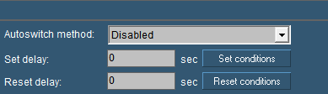

Figure 11‑20: Autoswitch

|  |  |
| --- | --- |
| **Autoswitch option** | **Explanation** |
| Autoswitch Method | Here you choose how the switch works  Disabled: not working  Set over Reset: Set is standard position  Reset over Set: Reset is standard position  Mimic Switch: for use in a mimic without attached sensor |
| Set Delay | Delay time for Set condition |
| Reset Delay | Delay time for Reset condition |
| Set conditions | Set conditions on how to react (see Figure 11‑21) |
| Reset conditions | Set conditions on how to react (see Figure 11‑21) |

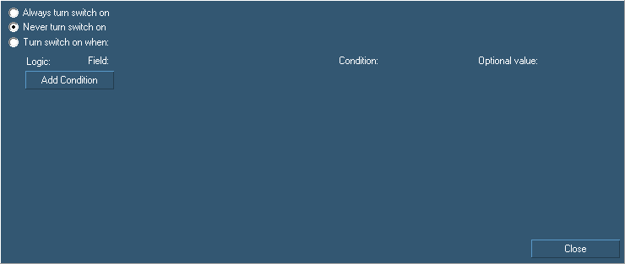

Figure 11‑21: Auto Switch Conditions

|  |  |
| --- | --- |
| **Autoswitch conditions** | **Explanation** |
| Always turn switch on | Switch is always on/visible |
| Never turn switch on | Switch is always off/unvisible |
| Turn switch on when | Let you add logic to turn a switch on |
| Add Condition | Alter the conditions that you need to make the switch work |

For example if you have a switch that turns on the bilge pump, you can also let it switch on when a certain event occur. So if you have a high alarm from that bilge, you can make the switch go on by saying so in the conditions field (see Figure 11‑22)

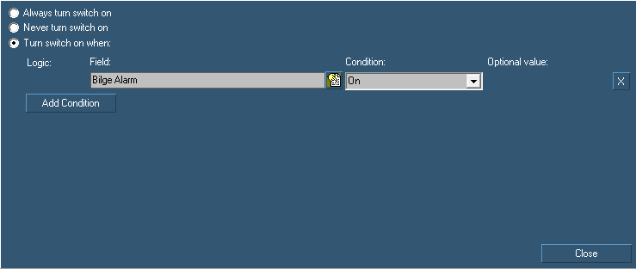

Figure 11‑22: Auto Switch condition

 Under conditions you find a lot of possibilities where you can experiment to get the right adjustments you need. For some of those you can refer to section 11.10.3.

### Log

For troubleshooting and examination purposes you can log all the fields. All the data coming in on each specific field can be saved to a log file.

Go to “Tools > Field Settings > Log” and choose the right field (e.g. Engine 1 Oil Pressure).

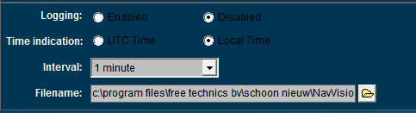

Figure 11‑23: Logging

#### Logging

Choose whether to enable or disable the logging on this field.

#### Time indication

Choose the time to be shown in UTC or Local time

#### Interval

Depending on the data on the field you can choose an interval her form 1 second to 2 hours. Useless to say that the log file is getting a lot bigger at an interval of 1 second. Be very precautious when using this.

#### Filename

Here you can chose the name and place where you save the log file.

### Logging with trending

When you have mimics available, you automatically have the possibility to make a trending mimic. Trending is very useful for troubleshooting and you can also use it to log activities.

In an empty mimic make a trending instrument (see Figure 8‑15). You will get the following instrument (see Figure 11‑24). At the right side you can choose the field that you want to see in your trend-instrument.

Click with your mouse on the box at the right side of the trending window. A dialog box will appear (see Figure 11‑25). Here now you can chose the field that you want to track.

Once you have chosen a field a new box will appear. Clicking on the colored line will take you to the color adjustment window, so you can give every trend a distinct color.

Moving your mouse over the trend-lines give you an exact date and time for every event on that line (see Figure 11‑26).

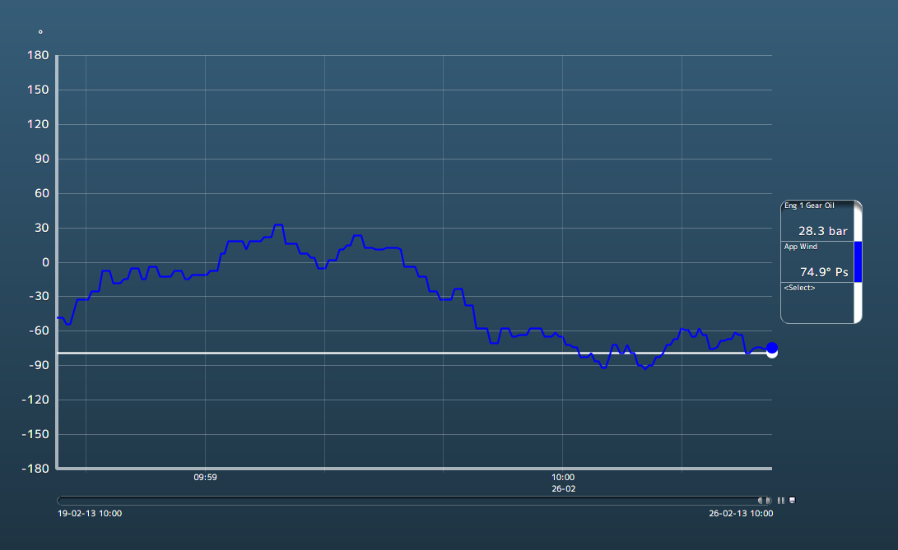

Figure 11‑24: Trending instrument

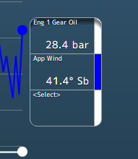

Figure 11‑25: Selection boxes

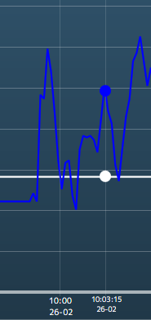

Figure 11‑26: time line

The line underneath the trending page is adjustable. You can take one of the corners to adjust the length of the trend to the interval time that you like to use (see Figure 11‑27).

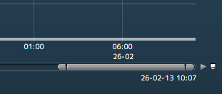

Figure 11‑27: Trending adjustments

Next to that line you can see a play button to make it interactive. You can play or pause the trending. Next to that is a save-icon. If you want to save the trending, click on the icon, find a place to save and give the file a name. FT NavVision® will save it to a .csv file that you can open with Excel (see Figure 11‑28).

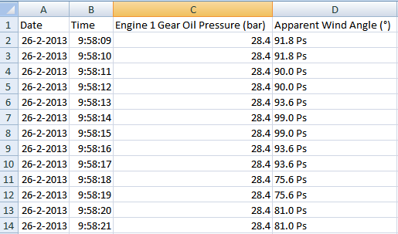

Figure 11‑28: Saved trending file

 *Save the log file to D: or any other disk that NavVision® ® is running on. If you save the log file on to c: (the embedded disk) you lose the log every time the system starts up again.*

## Alarm stations

The installation on board can be divided into different parts (alarm stations) which all can have different rights concerning the completion of alarms. Besides that it is proficient to have different rights for different groups onboard it is also prescribed by organizations such as Lloyds Register etc. there are preset names to choose from.   
These groups can be setup with specific alarm-rights. You can understand that the crewmess has other rights on alarms as the Engine Room or the Wheelhouse. Also the same goes for many other stations around the ship as there are the captain’s cabin, Flybridge, etc.

### Station Matrix

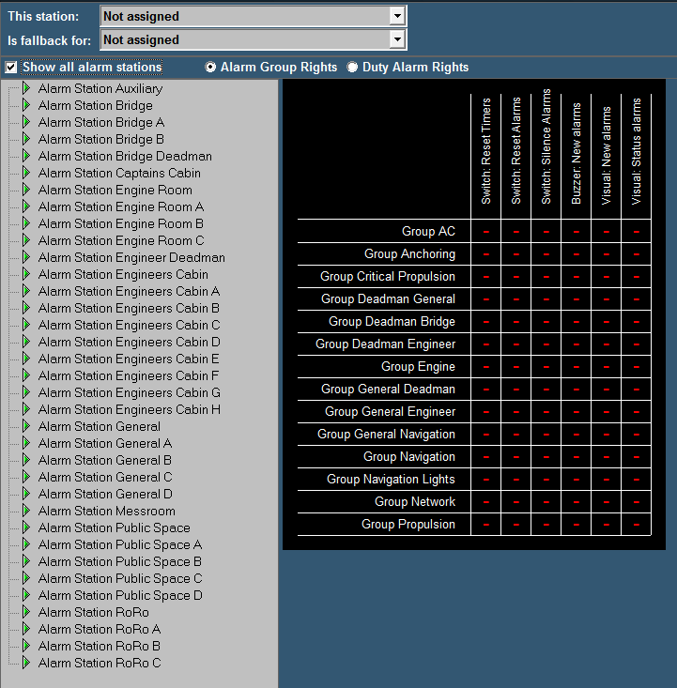

Figure 11‑29: Alarm stations

#### This station

Defines the station this computer is set on. All the alarm settings of that station are also valid for the PC screen you are working on. If set to “Not Assigned” no specific alarm restriction is set.  
All alarms will be visible and can be silenced or acknowledged.

#### Is fallback for

This defines which rights this computer will get once the station set in this box is not working. If this would be the wheelhouse pc it could be a fallback station for the engine room. When the engine room pc should be out for whatever reason, the wheelhouse station will take over the tasks and rights of the engine room pc. This way all the important tasks can still be handled.

 *In future releases this feature will be obsolete. By making all the stations a server that can work independently, there will be no need for this function.*

#### Show all alarm stations

Ticking this box switches between showing all, or all available Alarmstations.

#### Alarm group rights/Duty alarm rights

Choose either of these two to switch between changing alarm group rights or duty alarm rights.

#### Adjustments

On the left pane you can choose the alarm station to be adjusted. The adjustments will only be valid for that particular station. When you choose to set this station (i.e. Alarm station bridge) on an alarm panel or another Server or client, these will have the same settings automatically.

 *All the settings in the diverse alarm stations will automatically be set in all the other pc’s (servers and clients) which are connected. You won’t have to change all PCs separately. On the left panel you will find all the groups that are available in the system.   
Groups that are in use by the system are shown in the right pane. Other groups will not be available. You can set the alarm options for each separate group.*

*When finished, all alarm options of each alarm group will be set within the specific alarm stations.*

The following options are available:

|  |  |
| --- | --- |
| **Alarm group option** | **Explanation** |
| Visual: status alarms | Shows any alarm even if it is acknowledged |
| Visual: new alarms | Shows new alarms for this group |
| Buzzer: new alarms | Sounds buzzer on new alarms for this group |
| Switch: silence alarms | Allows to silence the alarms for this group |
| Switch: reset alarms | Allows to acknowledge the alarms for this group |
| Switch: reset timers | Allows resetting of timers (i.e. dead man’s timer) |

#### How to set

Fields are set separately by pointing the mouse onto that field and right click it. The “Reset” fields will turn to “+” and the other fields will turn to “0” which simultaneously means that the delay is set to “0” minutes.

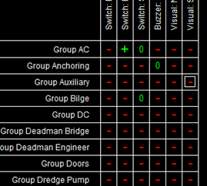

If you want to set a field to a higher delay (i.e. you want to silence an alarm for 3 minutes) you must left click the field. A menu will appear where you can change the settings including the delay time. Check “Enable the selected cells” and choose a delay time. You can choose the delay time in minutes or seconds by checking the appropriate box (see Figure 11‑30).

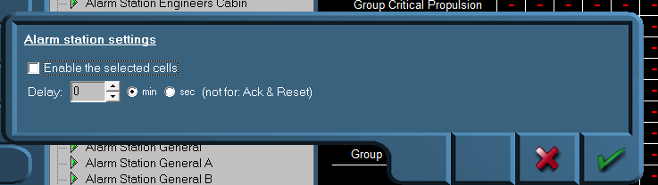

Figure 11‑30: Alarm station settings

In addition, you can do this for different cells at the same time, by clicking and dragging the mouse over the preferred cells (see Figure 11‑31).

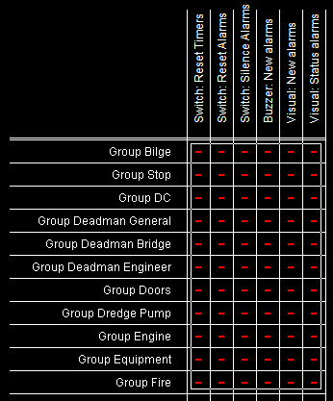

Figure 11‑31: Select by dragging

If you want to disable the alarm settings, deselect the checkbox “Enable the selected cells”.

#### Background

To elaborate a little bit further we will explain a bit more about the use of alarm stations. Each station will be in a particular part of the ship (i.e. wheelhouse, engine room, crewmess, chief engineer cabin etc.) All these stations have their own rights on which alarms they can hear or see and how they can act upon such an alarm. For example, the engine room is the place where all the alarms normally will be visible and almost always the only place where alarms can be acknowledged. This is because regulations require that alarms can only be acknowledged on that part of the ship where you can act upon the alarm and take precaution action on that alarm. Now in the crewmess (a public space) all kind of people have access to the workstation. It is not advisable that these people have rights to acknowledge the alarm. So in this space you can set the Alarmstation rights for the crewmess, so that they don’t have the rights to acknowledge.

You can imagine that in the wheelhouse they do not want to see all the alarms concerning propulsion etc. merely navigational alarms are mostly enough on the bridge. Here you can set the alarm stations to only show navigational alarms and not propulsion alarms.

We have developed a lot of standardized settings for different variations. Please refer to the troubleshooting manual for these examples.

### Alarm Panels

Often we use smaller panels as a workstation in various rooms (especially the smaller cabins and messroom), these panels are called DAP (Duty Alarm Panel). DAP’s have to be pointed out to the system. Under Alarm Stations>Alarm Panels you can set these DAP’s (see Figure 11‑32).

See also chapter 9.5

|  |  |
| --- | --- |
| **Alarm group option** | **Explanation** |
| MAC | Type the MAC-address of the DAP here |
| Alarm Station | Choose which station it will represent (for alarm settings) |
| DAP Type | Choose the type of DAP in use |
| IP | IP address in range 172.xx.0.81 and so on |

 *After changing these settings choose “ accept and restart communication” to activate the changes.*

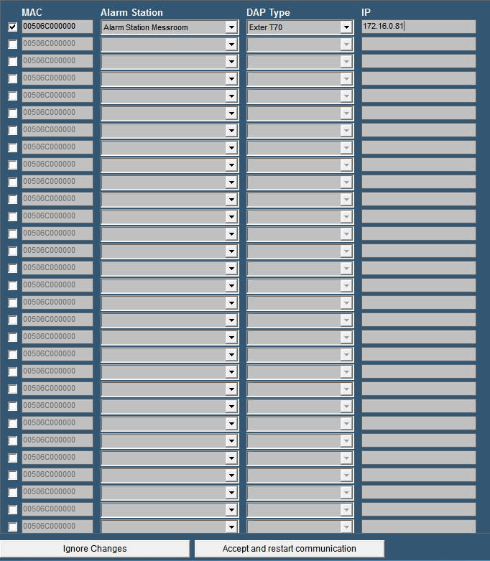

Figure 11‑32: Alarm Panels

### Alarm groups

In Alarm Groups you can define the looks of the DAP’s (see Figure 11‑33).

Under “duty alarm panels” you can set the rows and columns that you want to see if they are in alarm. You can choose up to 2 rows and up to 5 columns. Under “assigned alarm groups” you can define which alarm group you will see. Just click on a field and choose the specific alarm Group.

“This Station” defines the look and feel of the OWS. In default mode you have the same layout as a standard alarm page. You can also choose to only see a list of alarms or a list of alarms with the controls for silencing etc.

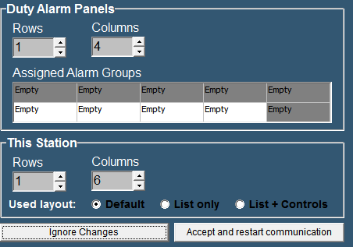

Figure 11‑33: Alarm Groups

 *After changing these settings choose “ accept changes” to activate the changes.*

### Alarm Settings

Here you can specify different alarm settings.

Under “Duty Alarm System” you can choose the following:

Automatic deactivate of public space When ER attended: if you do not want the alarms to sound in all the public spaces when there is someone at watch in the ER

Alert duty Cabin When ER turns unattended: To notify the person on duty that there is nobody in the ER anymore and his watch begins.

Alert Bridge when ER turns unattended: Just for convenience.

Under “Personal Alarm Settings” you can choose if the deadman timer starts again with every new alarm.

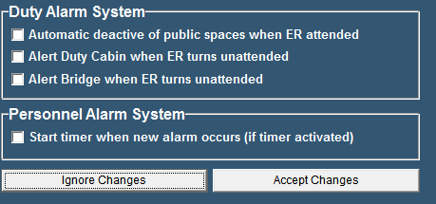

Figure 11‑34: Alarm Settings

## Preferences

### General

With the field “Preferences” (see Figure 11‑35), you can set several personal preferences. For example, you can set the software language, set the ships heading references as well as configure the SMS service.

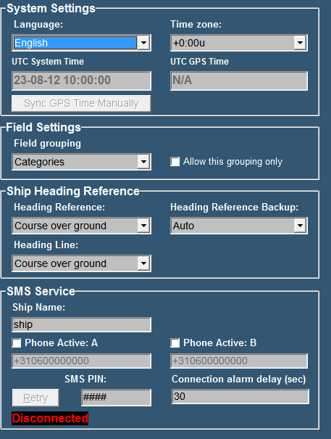

Figure 11‑35: Preferences

### System Settings

By clicking the “Language” arrow, all supported software languages appear.

Simply click on one of these languages to set the default language for all software modules.

By clicking the “Time zone” arrow allows you to set the relevant UTC[9] time zone.

As soon as a GPS is connected to the system NavVision® will use this GPS to set the time. In this case you won’t have to alter the “Time Zone” while it will be taken care of by the GPS. If you think the time is not right, you can click “ Sync GPS time manually”.

### Field Settings

Under “Field Grouping” you can choose in which order you want to see all the fields in “field settings”. You can change the order to “Categories” or to “ Alarm Groups” The last one will come in handy when you are checking whether all the fields are in the right Alarm Group.

### Ship heading reference

This option allows you to choose the default references for heading, heading backup and heading line. The options range from Auto to Course over ground, Gyro compass, true compass and magnetic compass.

### SMS service (ship name)

Ship name is used to enter your ship’s name into the software. Of course, the name is entirely your own choice and has no influence on the software’s functions.

### SMS service (phone active A & B)

 *When entering a phone number always include your country code.*

Phone activate A/B are used to store the telephone numbers of one or two mobile phones you want to receive text-messages with. First, tick off the checkbox for each phone in use and enter the phone-number of your choice.

### SMS service (SMS PIN)[10]

Via the field SMS PIN, enter a personal code (any combination), used to establish a connection in between your phone and the system. The black box below shows whether a connection is established or not.

|  |  |
| --- | --- |
| **Detail** | **Description** |
| Connected | Indicates that a connection is made. Alarm messages are allowed to be sent to your mobile phone. |
| Disconnected | Indicates that no connection is made. No alarm messages to be allowed. |

## Taskbar

### General

To open the NavVision® taskbar menu, select “Tools > Taskbar”.

The taskbar menu is used to configure the taskbar.

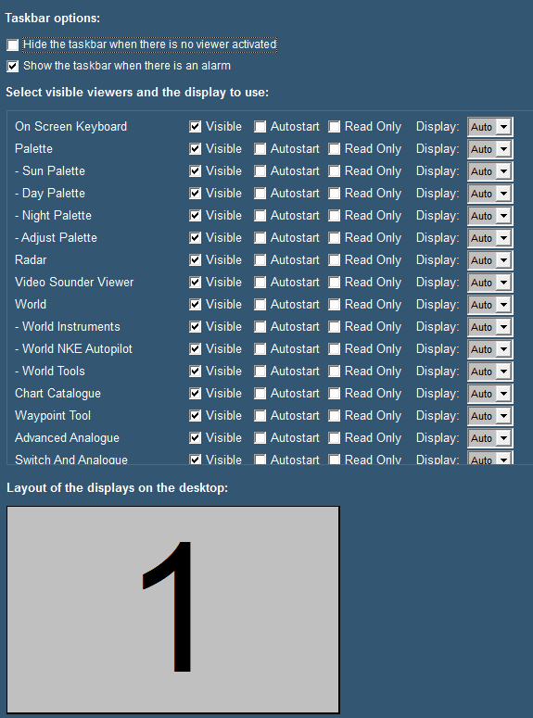

Figure 11‑36: Taskbar menu

The following taskbar settings are available:

|  |  |
| --- | --- |
| **Setting** | **Description** |
| Hide the taskbar when there is no viewer activated | This option allows you to hide the taskbar, in case all viewers are inactive. This function can be disabled, by moving the mouse cursor to the top of the screen. |
| Show the taskbar when there is an alarm | This option allows the taskbar to appear whenever an alarm occurs. This overrides the previous setting of the hidden taskbar. |
| Visible | This option allows you to select the availability of viewers. You can select the viewer that must be displayed and be accessible through the taskbar or not. |
| Autostart | The second option enables you to determine the viewers that automatically open at startup of the software. |
| Read Only | This option prevents people to alter settings in the viewer or mimic |
| Display | The display box defines the screen used for each viewer. The number shown symbolizes the displays as shown at the bottom of the screen. “Auto” means that it will appear at the first free screen. If there is a number, the viewer will appear on that screen. Only available if you have more screens attached. |
| Layout of the displays on the desktop | This setting allows you to show the placement of the different screens connected to your system. The display order, size and the number available for display of viewers are shown. |

*: As of release 3522 it is possible to hide the “close” button to make sure people do not shutdown the program accidently. Just uncheck the checkmark box for the close button*

*:As of release 3632 it is possible to groupviewers under one button by selecting “Viewer group”*

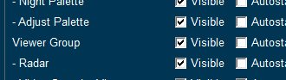

Figure 11‑37: viewer group

## GPS/NMEA

### General

The GPS/NMEA page is merely a reference to check data. You can use it to see if data from GPS or NMEA devices is coming into the system and if the data is right.

### GPS calculates the position in/The position is shown in

These two fields can be used to change the calculating method of the GPS sets. In almost any case you can leave them as they are.

### Trace of received NMEA data

In the window below the text you will find all the NMEA data that is coming in. With the eraser you can clear the data from the window. By checking/unchecking the box from “Rx” or “Tx”you get respectively only received, only transmitted or all data.

If the string you see in the window is green, the data is recognized by NavVision® and can be processed. This doesn’t directly mean that the data is correct, but only that the string is sent in the right style. If the string is grey, it is no longer available or not in the correct style and won’t be processed by NavVision® .

*: While NavVision® repeats a lot of NMEA data for multiple purposes, it is wise to uncheck the “Tx” box when you are checking the incoming data.*

## Configuration

### General

Under configuration you will find all the tabs that you can use to configure and fine-tune the NavVision® system. Some of them are still in progress and will be available soon. You do not need them know. All the other features we will discuss here.

## License

To give rights to use a specific part of the software, NavVision® uses licenses to open up these parts of the software. Depending on which licenses are bought, viewers will be visible and strings will be processed (see Figure 11‑38).

Under “License” you can see which viewers, communication etc. are opened in your version. If you see a license and it is green, this means that the license is valid. If the license is red it is not valid. If there is no license and the stripes in the box are green or red it means the same, only than the license is freed up by another license (i.e. Navigation Pro license will also open up NMEA, so the stripes under NMEA will be green).

Normally you won’t have to alter anything here. Free Technics will provide you with a “Key.uc.ini” with all the necessary licenses available. The program will read the licenses from the ini-file and put them in place at startup. Sometimes however you can check here if you miss a certain viewer or if a communication protocol doesn’t seem to work. If you are missing a single license, you can fill it in here and it will be set in the ini-file as well.

*: Missing licenses are also mentioned in the logbook. Please refer to the section “Logbook” for more information.*

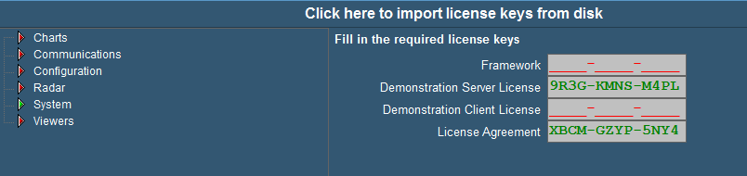

Figure 11‑38: License

## Serial

### General

Under “Tools > Configuration > Serial” the following menus are available;

* COM ports
* Serial LAN ports
* CAN ports
* MasterBus Devices
* Overview connected devices.

### COM ports

Under “Tools > Configuration > Serial > COM ports” (see Figure 11‑39) all COM ports as found by NavVision® become visible. At the first startup they are no COM port yet assigned (i.e. COM port menu does not show any COM port data).

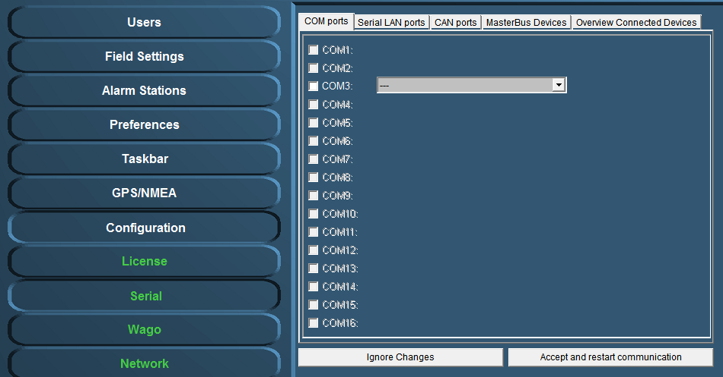

Figure 11‑39: COM ports

#### COM port assignment

 *Use the right device interface (protocol) and verify the baudrate etc.*

Check the respective wiring schematics to determine the COM port arrangement and assignment. Tick off the relevant COM port (1, 2, 3, etc.) and select the required device interface (protocol) by means of the drop-down menu (see Figure 11‑40).

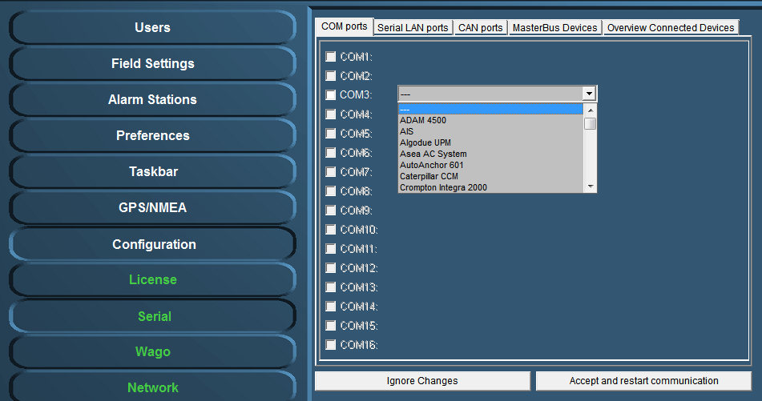

Figure 11‑40: Drop-down menu (device interfaces)

At completion, confirm the settings by clicking “Accept and restart communication” (see Figure 11‑40).

Check the appropriate NavVision® viewer to verify if the COM-port is correct and if there is any data communication. For example: select the “Video Sounder” viewer (see Figure 11‑41) to verify that the device interface (protocol) on “COM1” is correct. Repeat this procedure for all other listed COM ports.

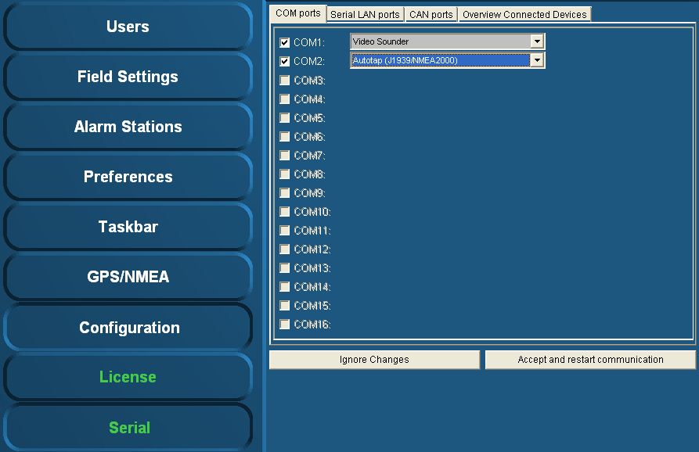

Figure 11‑41: COM port assignment

Additional information on the selected port can be configured by clicking on the sign behind the drop-down menu (see Figure 11‑42). A new box will open.

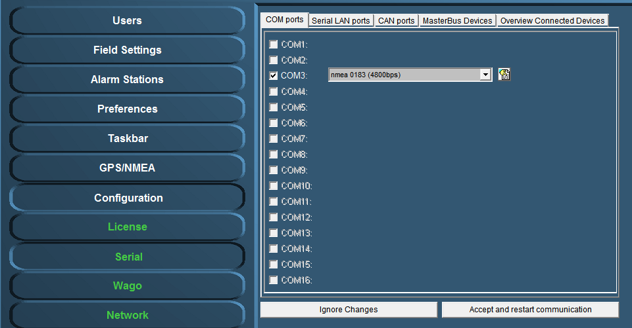

Figure 11‑42: additional configuration

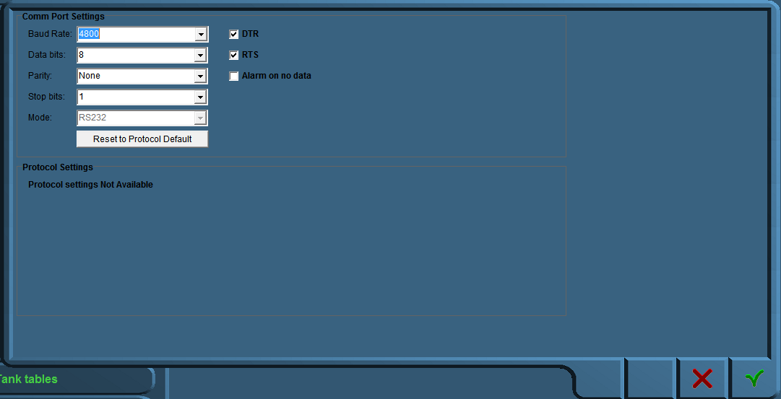

Figure 11‑43: Comm Port Settings

In this additional configuration menu (see Figure 11‑43) you can force all the settings for the regarding Comm port. The following fields apply:

* Baud Rate: Set the appropriate baudrate (see manual attached device)
* Data Bits: The number of data bits in each character can be 5 (for Baudot code), 6 (rarely used), 7 (for true ASCII), 8 (for any kind of data, as this matches the size of a byte), or 9 (rarely used). 8 data bits are almost universally used in newer applications. 5 or 7 bits generally only make sense with older equipment such as teleprinters.
* Parity: The parity bit in each character can be set to none (N), odd (O), even (E), mark (M), or space (S). None means that no parity bit is sent at all. Mark parity means that the parity bit is always set to the mark signal condition (logical 1) and likewise space parity always sends the parity bit in the space signal condition. Aside from uncommon applications that use the 9th (parity) bit for some form of addressing or special signalling, mark or space parity is uncommon, as it adds no error detection information. Odd parity is more common than even, since it ensures that at least one state transition occurs in each character, which makes it more reliable. The most common parity setting, however, is "none", with error detection handled by a communication protocol.
* Stop Bits: Stop bits sent at the end of every character allow the receiving signal hardware to detect the end of a character and to resynchronise with the character stream. Electronic devices usually use one stop bit.
* Mode: In mode you can set the protocol that the serial port is using to communicate. Refer to your device for the proper protocol. You can choose between RS232, RS422 and RS485. In some occasions you can’t choose Mode cause the interface protocol can only work in a predefined Mode (i.e NMEA is always RS232).
* DTR: Data Terminal Ready, indicates presence of DTE to DCE (set high or low)
* RTS: Request to send, DTE requests the DCE prepare to receive data (set high or low)
* Alarm on no data: Gives an alarm when there is no data on the Comm port
* Reset to protocol default: Resets standard configuration for chosen protocol

### Serial LAN ports

Under “Serial LAN ports” (see Figure 11‑44) the attached serial LAN device can be addressed and when necessary be calibrated.

The following fields are available;

* Serial LAN server
* Type (serial LAN server)
* IP address
* MAC address
* Data/control port
* LAN1 and LAN2

After installation a calibration procedure must follow, to ensure that the LAN device will function properly.

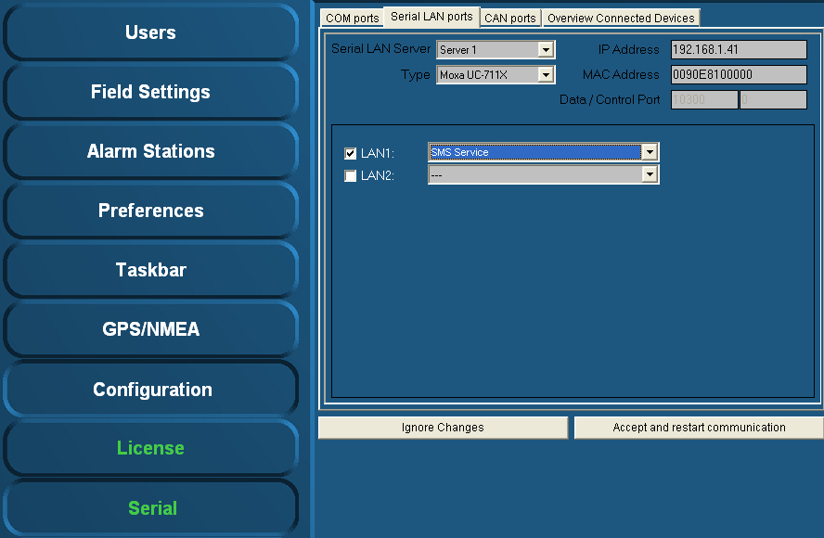

Figure 11‑44: Serial LAN ports

#### Serial LAN server

Under “Serial LAN ports > Serial LAN server” (see Figure 11‑45) the server to be assigned can be selected. In addition under “Type” the LAN server type can be selected.

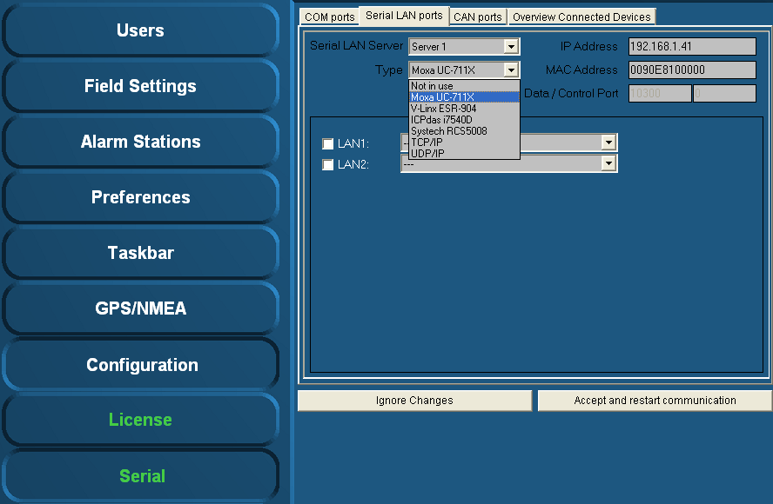

Figure 11‑45: Type (Moxa)

#### Type (Moxa UC-711X)

The Moxa is found under “Type” > “Moxa UC-711X” (see Figure 11‑45).   
Fill in the IP address of the Moxa unit under “IP Address” (use same range as the PC i.e. 172.16.x.x, for Moxa the last digits are in the 40 range).   
The very first connected Moxa unit is set to IP address 172.16.1.41 and the next available to 172.16.1.42 etc.

*:*

*The MAC address can be found on the sticker underneath the unit.*

For the Moxa unit it is necessary to use a MAC address specified under “MAC Address”.

If necessary, verify the LAN1 and/or LAN2 settings and choose the appropriate device interface / protocol (see section 11.9.2.1).

To confirm the settings, click “Accept and restart communication” and verify if the serial data is working within NavVision®.

#### Type (V-Linx ESR-904) *Obsolete*

The V-Linx is found under “Type” > “V-Linx ESR-904” (see Figure 11‑46).   
Fill in the IP address of the V-Linx unit under “IP Address” (use same range as the PC i.e. 172.16.x.x, for V-Linx the last digits are in the 40 range).  
The very first connected V-Linx unit is set to IP address 172.16.1.41 and the next available to 172.16.1.42 etc.

*:*

*Please be aware that multiple units (i.e the Moxa’s) will operate within the same IP address range (172.16.1.4x). Use different IP addresses, otherwise the system may not function properly.*

Verify the LAN1 - LAN4 settings (if available) and select the appropriate device interface / protocol (see 11.9.2.1).

To confirm the settings, click “Accept and restart communication” and verify if the serial data is working within NavVision®.

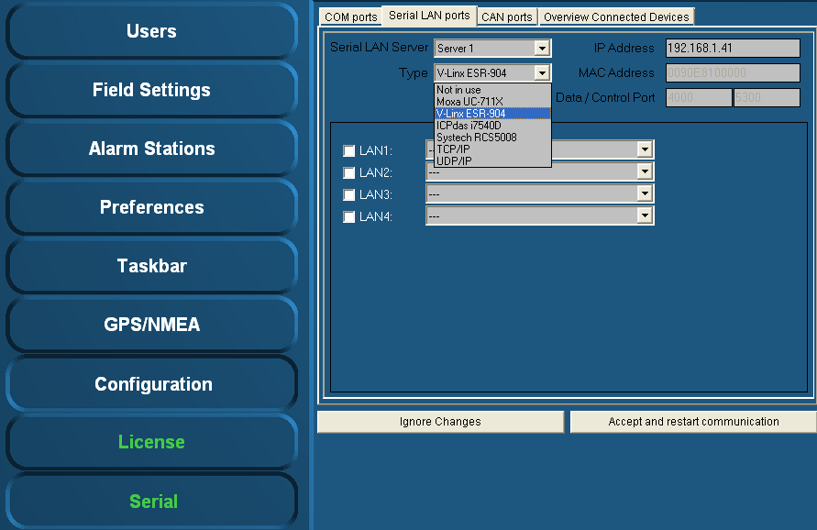

Figure 11‑46: Type (V-Linx ESR-904)

#### Type (ICPdas i7540D)

The ICPdas is found under “Type” “ICPdas i7540D” (see Figure 11‑47).   
Fill in the IP address of the ICPdas server under “IP Address” (same range as the PC i.e. 172.168.x.x, for ICP the last digits are in the 30 range).

The very first connected ICP is set to IP address 172.16.1.31 and the next available to 172.16.1.32 etc.

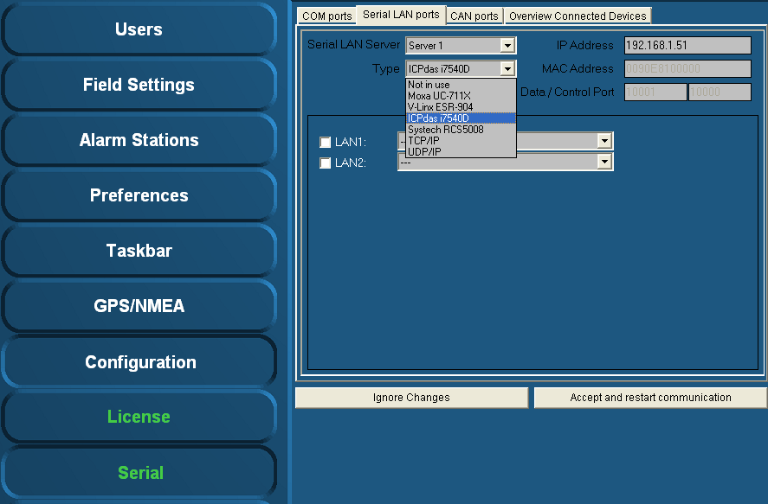

Figure 11‑47: Type (ICPdas i7540D)

Verify the LAN1 and LAN2 settings (if available) and select the appropriate protocol (see 11.9.2.1).

To confirm the settings, click “Accept and restart communication” and verify if the serial data is working within NavVision®.

### CAN ports

Under “Serial > CAN ports” the following menus are available:

* Interface
* Standard
* IP
* Group.

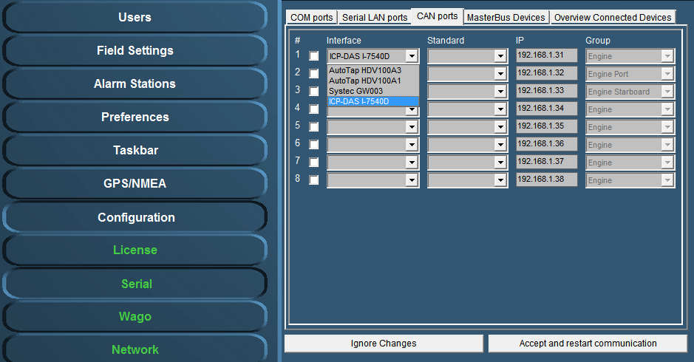

Figure 11‑48: Interface

Under interface you can choose different kinds of Can-interfaces. The most used one is the ICP. If you come across an older version, you can choose it here. (see Figure 11‑48).

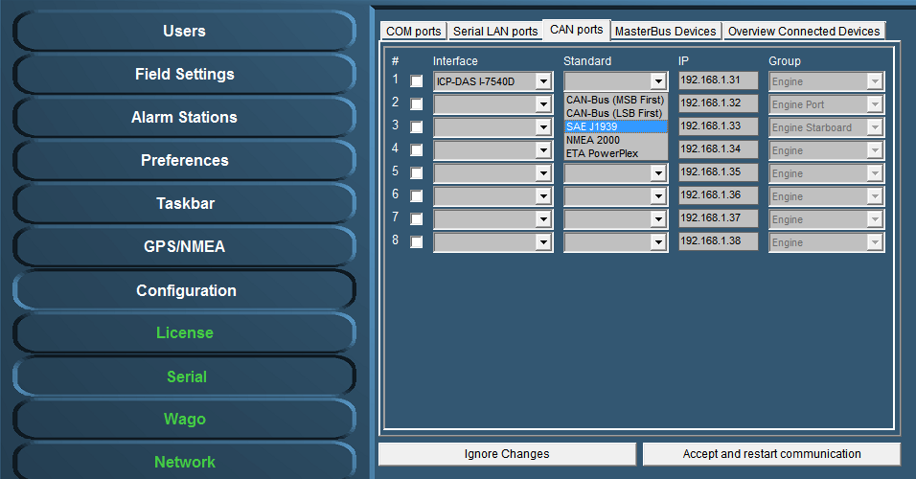

Figure 11‑49: Standard

Under Standard you choose the protocol you want to use with the interface (see Figure 11‑49). Most widely used are the NMEA 2000 and the SAE J1939. Which to use is depending on your attached protocol.

Under IP you can select the right IP address that reflects the connected ICP for example. You can best leave it as it is by default (which will become the 172.16.1.x range). For information on how to set the right IP-address in the ICP, please refer to the ICP installation manual.

The group you choose reflects under which group the information will be stored in NavVision. If you, for example, want the information from the interface to show up under Engine Port, you select that under Group (see Figure 11‑49).

After each change you need to hit “Accept and restart communication” to save it to the system.

### Overview connected devices

 *The installation of serial devices may require some calibration. For example, it may be possible that you need to make some adjustments in the “INI-files”. For more detailed information on this subject please refer to Free Technics .*

Under “Serial > Overview Connected Devices” (see Figure 11‑50) an overview of the connected devices is shown.

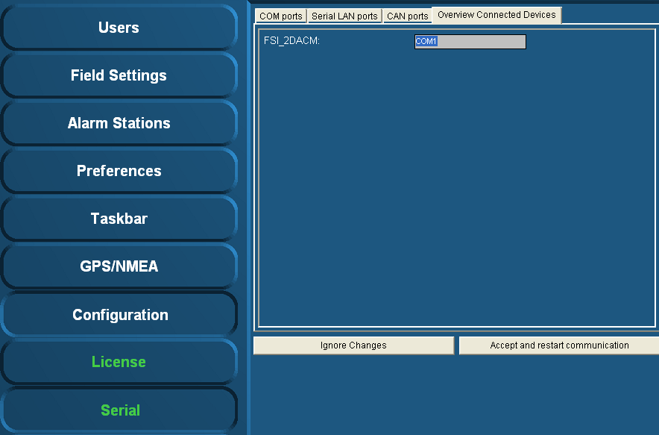

Figure 11‑50: Overview connected devices

### IP-Address standardization

For standardization purposes the same IP-addresses are used throughout each system. In the table below you’ll find the IP-addresses (standard protocol) for most instruments.

|  |  |
| --- | --- |
| **Detail** | **IP-Address** |
| PC I/O | 172.16.x.x (172.16.24.35 for key number 2435) |
| PC I/O next ring | 172.17.x.x (172.17.24.35 for key number 2435) |
| Duty Alarm Panels  (DAP) | Using range x.x.1.8y  Depending on the network connected, this will result in:  DAP 1: 172.16.1.81  DAP 2: 172.16.1.82  DAP 3: 172.16.1.83 |
| Serial LAN servers | Using range 172.16.1.4x (attached to I/O subnet 172.16) INT 1: 172.16.1.41 INT 2: 172.16.1.42 INT 3: 172.16.1.43 |
| Wago | Using range 172.16.1.9x (attached to I/O subnet 172.16) Wago substation 1: 172.16.1.91 Wago substation 2: 172.16.1.92 Wago substation 3: 172.16.1.93 |
| CAN-Interface | Using range 172.16.1.3x (attached to I/O subnet 172.16) CAN interface 1: 172.16.1.31 CAN interface 2: 172.16.1.32 CAN interface 3: 172.16.1.33 |
| Axis | Using range 172.16.1.24x (attached to I/O subnet 172.16) Axis cam server 1: 172.16.1.241 Axis cam server 2: 172.16.1.242 Axis cam server 3: 172.16.1.243 |

## Wago

### General

Under “Tools > Configuration > Wago” (see Figure 11‑51) all detected and connected Wago devices become visible including the server to which they are connected to.   
You can check the MAC-address and see if the Wago is connected or not.

In general, by means of the sensor list changes are made. But for minor changes or to improve the control of the device, please refer to this menu.

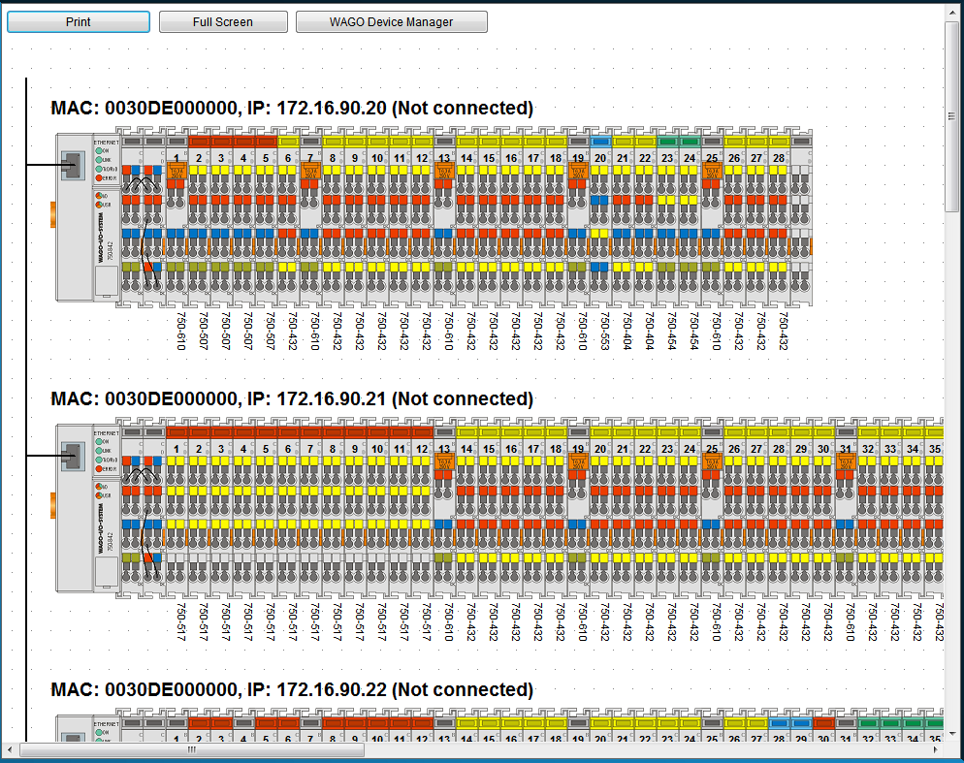

Figure 11‑51: Wago configuration

|  |  |
| --- | --- |
| **Detail** | **Description** |
| Print | Print the separate Wago-layouts for your convenience |
| Full Screen | Shows the Wago-layout full screen |
| Wago Device Manager | Opens a new window where you can set specific configuration settings |

When you click on a Wago, it will expand and show you the separate slices with the connected fields (see Figure 11‑52). Here you can fine-tune the selection, troubleshoot problems and calibrate sensors.

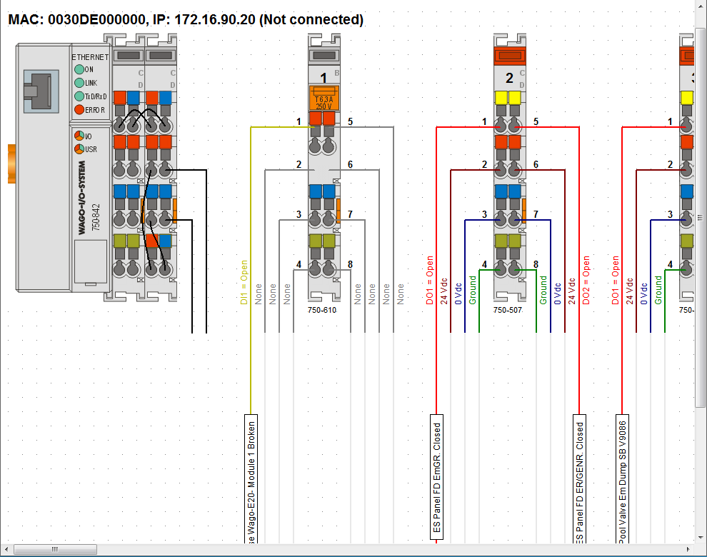

Figure 11‑52: Wago expanded view

### Adding a field to the Wago

If you want to add a new field to a Wago slice, just click on the field name box of the specific slice. If there was not already a field attached, the box will be blank (named sensor). By clicking it you will open a new window that shows all the fields within NavVision® (see Figure 11‑53)

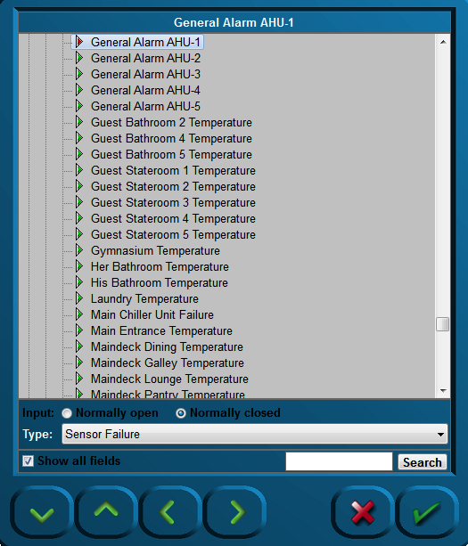

Figure 11‑53: Sensor-window

The following choices are possible:

|  |  |
| --- | --- |
| **Detail** | **Description** |
| Input | NO or NC |
| Type | The behavior of the field (see 11.10.3) |
| Show all fields | Toggling between all fields and fields available |
| Search | Search for a specific field |

### Wago “Type” explanation

The Type architecture needs some extra explanation. Each field in NavVision® has its own behaviour. It can be an alarm, a status, or an analogue value. Sometimes you need to give a field a specific task. As add-on to its original task, or if the field is just a standard field.

By default the sensor will have “standard” as its type-value. This will set the behavior to the standard mode of the field. The choices you have and their behavior will be explained in the next paragraph.

### Type and behavior

Under “Type” (sensor type) a variety of sensor types can be chosen. The most commonly used types are described.   
Click the arrow button of the dropdown menu to open the sensor type list (see Figure 11‑54).

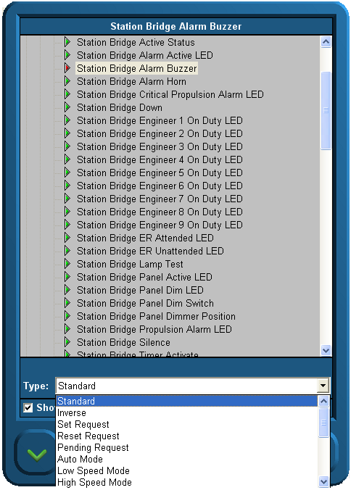

Figure 11‑54: Sensor type list

#### Alarm

If the connected field isn’t a specific alarm field (see “Field Settings > Alarm”) it is possible you still like it to act as an alarm. Just set the type to Alarm.

#### Alarm Buzzer

If a field has to react at the same pace as an alarm buzzer, you can choose this type. If you, for example, put it on an output, You can let a lamp blink as the alarm goes off.

#### Alarm Status

Sometimes you need to feed a led-board to show all the alarms on a separate place. With type Alarm Status, you can set a field to set high if this field is in alarm. This way you can feed a led-lamp.

#### Auto

Auto is used in the combination Auto/Manual. If you choose this type, you can see when a sensor is ready to be controlled through NavVision®.

#### Closed

Does the same as the set/reset request but then on the DI. Look at a specific sensor to find out that it is functioning. When on is detected it knows the position is closed.

#### Failure

It is the same as status, but in this case mostly used as a setting to check whether the sensor is in failure. It is used to set failure status on bulb failure or as general alarm from attached devices.

#### High

See low alarm.

#### High Level

See low alarm.

#### Impulse

If an impuls relay is connected to a DO you don’t want to generate a constant voltage. Put the status on “Impuls Relay” and the DO will give a short pulse when triggered.

#### Lamp

If, in addition to NavVision®, you also need to show the lights on an analogue panel, it is wise to give all the lights the type “Lamp”. This way it will be possible to use the lamp test function. By using this function, all the fields with “Lamp” as type will lit up once the lamp test is pressed. Also you can use it to test the real lights. When pressing the lamp-test button you can check all the bulbs.

#### Low

If the connected FT-field isn’t a specific alarm field (see “Field Settings > Alarm”) it is possible you still like it to act upon an alarm. For example if you have the field “Fresh water level” you could like to have an alarm when the tank is almost empty. Here is where you can put the status to “low alarm”. The system will identify it as an alarm field and will consequently show the alarm on the alarm panel and logbook. Note that it states “ext.” on the alarm panel to indicate that it is an external alarm.

#### Low Level

See low alarm.

#### Off Lamp

See Lamp.

#### On Lamp

See Lamp.

#### Open

Does the same as the set/reset request but then on the DI. Look at a specific sensor to find out it is off. When off is detected it knows the position is opened.

#### Pending

Used on a DO. Once selected it gives a signal as long as the particular task is not fulfilled. I.e. in a mimic you can show by a blinking icon that the action is still taking place.

#### Pulse

When a sensor needs a short pulse instead of a steady signal, use Type “Pulse”.

#### Push

Same as Switch, but then used as a second type for the same sensor. Also used to control the sensor through a mimic button.

#### Ready

When the sensor is ready for use, “ready” will get high.

#### Remote

Used in conjunction with Local. To see if the sensor can be controlled locally or remote.

 *Local is at the sensor and remote is in NavVision®.*

#### Request

See Switch.

#### Reset (Request)

 *Does not function without Digital In (DI) status.*

The “Reset request” signal output in general is a Digital Output (DO).

Once selected, a request will be set to the attached sensor (e.g. a valve or other device that can be steered to open), and it will stay set until it gets a status back that the request is fulfilled. Needs to be combined with a DI where the status of the sensor will be connected to (i.e. open/close).

#### Running

DI that is coming from the sensor to show that it is running. Used to measure the total time etc.

#### Running Hours

Internal calculation. Once the sensor is high, this field will start the count for running hours based upon the time that the sensor is high (also when switched on but not running, so less accurate).

#### Set (Request)

 *Does not function without Digital In (DI) status.*

The “Set request” signal output generally is a digital output.  
Once selected, a request will be set to the attached sensor (e.g. a valve or other device that can be steered to open), and it will stay set until it gets a status back that the request is fulfilled. Needs to be combined with a DI where the status of the sensor will be connected to (i.e. open/close).

#### Standard

This is the standard setting. Via this setting nothing extra will be added to the field. Leave it on standard if nothing else is required or if you don’t know.

#### Standby

See Ready.

#### Status

Is general used on DI. If you need to know the status on an attached sensor but that sensor is in use by the PLC-program, you can use status in the Wago configuration. Now it reads the status of the sensor without interfering with the PLC-program.

#### Switch

When a switch is connected to a DI (i.e. an external pushbutton) you must set the status to switch. A box will appear which reads “request”. Now Wago will know that it has a switch connected and will act accordingly. If this status isn’t set upon a hardwired button, this button will not work.

#### Timeout

Some sensors, i.e. valves, have a separate connection to show that the action has timed out. When not available use Timeout as type. If no signal is coming back (DI) within a certain amount of time, it will give a timeout.

#### Too High

See low alarm.

#### Too High Level

See low alarm.

#### Too Low

See low alarm.

#### Too Low Level

See low alarm.

### Wago Device Manager

Under “Configuration > Wago > Wago Device Manager” the following window appears:

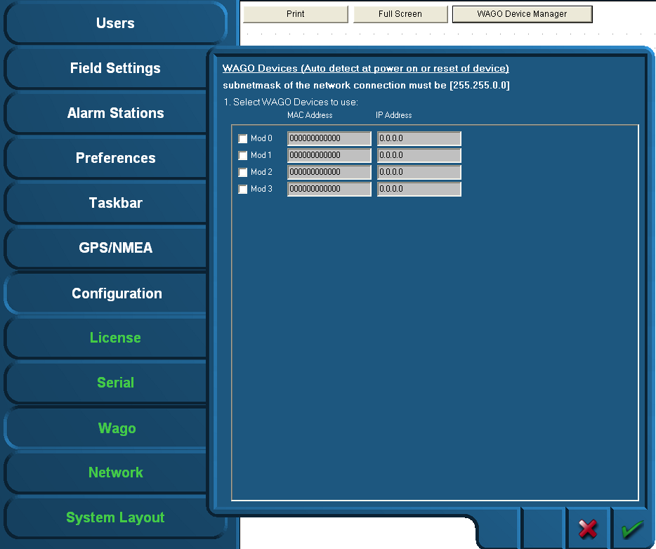

Figure 11‑55: Wago Device Manager

When the devices are correctly installed and connected, the respective MAC addresses will be shown via the “Wago Device Manager” window. The “Mod0” and others that are found are shown green. If a Wago is specified with an IP address and there is no connection, the Text will be red. (see Figure 11‑56)

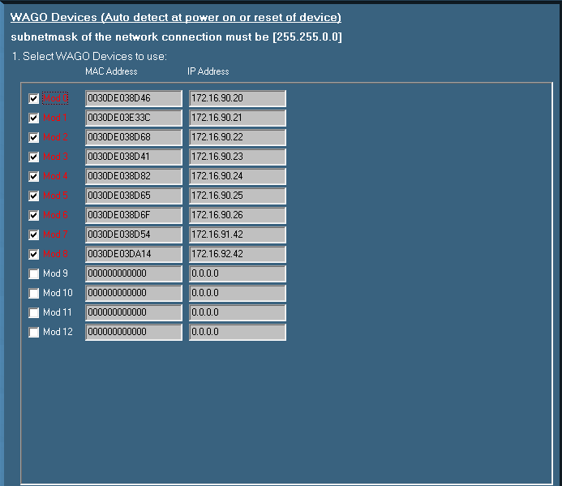

Figure 11‑56: Device Manager

If the MAC addresses does not show, it is possible that there is no connection with the specific Wago or the Wago devices need to be restarted. This can be accomplished by

* Disconnecting electrical power from the Wago device for a short period of time
* By pushing down the operating mode switch (see Figure 11‑57).

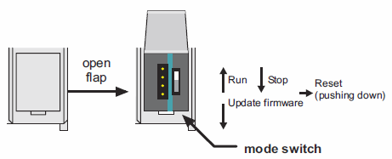

Figure 11‑57: Operating mode switch (Wago)

The operating mode switch (see Figure 11‑57) is a push/slide switch with 3 settings and a hold-to-run function.

|  |  |
| --- | --- |
| **Operating mode switch** | **Function** |
| From center to top position | Activate program processing (RUN) |
| From top to center position | Stop program processing (STOP) |
| Lower, bootstrap | For original loading of firmware, not necessary for user |
| Push down (i.e. with screwdriver) | Hardware reset.  All outputs and flags are reset; variables are reset to 0 or to FALSE or to an initial value.  Retain variables or flags are not changed.  The hardware reset can be performed with STOP as well as RUN in any position of the operating mode switch! |

If the device manager shows a MAC address, check this against the MAC address on the head station on the Wago. If it is right, click the check box.

Fill in the IP address the Wago device (must be in the same range as the PC, i.e. 172.16.x.x).  
For Wago the last digits are in the 90 range. The very first connected Wago will be set to 172.16.1.91 and the next available to 172.16.1.92 etc.

Confirm the settings by clicking the “OK” button. The screen will show the connected Wago devices, their respective MAC addresses, their given IP addresses and the server they are connected to.

### Wago calibration

In Wago you can calibrate the analogue sensors, which is especially proficient when it is non-linear. As example we’ll show the calibration of a tank.

The best steps to calibrate the tank sensors are as following:

1. Shut down all the NavVision installations (i.e. other servers and clients) except for one server. This must be done to make sure this server's calibration will not accidentally be overwritten by any other system on the network
2. On the running Server system, open the Wago configuration and follow the next steps for every field
3. Press the “W” on the (i.e 750-454) modules containing the tank level sensors. The 750-454 modules measures 4 to 20 mA (see Figure 11‑58)
4. You now see the old calibration or the standard linear one. Be aware of the measuring unit used.  
   The graph (see Figure 11‑59) shows the unity on the Y-axis; depending on the actual field settings
5. Write down the measured mA for an empty tank. The measured mA is shown below the graph.

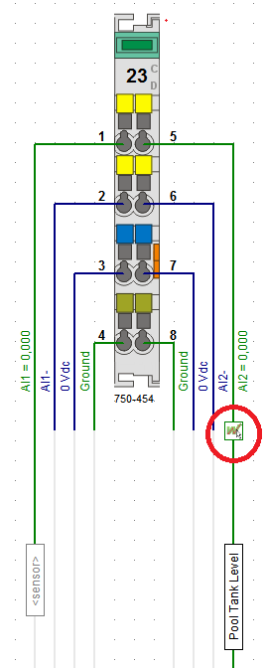

Figure 11‑58: Calibration

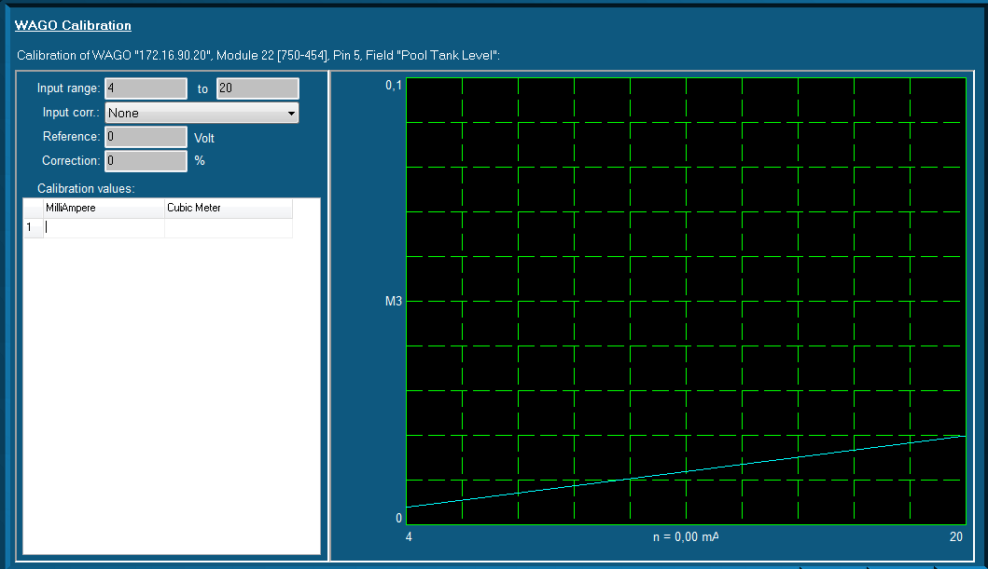

Figure 11‑59: Graph (WAGO calibration)

You can enter this value in the first row/first column of the table. In the right column, enter “0”. This column is the amount of unity's noted down in step four.

You now have configured that this amount of mA gives “0” (gallons/liters/...)

1. Fill the tank until you see the mA changing.   
   Depending on the sensor, it can be that the first amount is not measured
2. Write down this mA and amount of liters/gallons (depending on the unity) on the next row
3. Repeat the filling/noting down the values steps as much times as you like. If the tank is completely linear, four times could be a good choice. If not, it's better to make more measurements concerning the odd-shaped part of the tank
4. Finally, be sure to take a measurement with a full tank. You now see the blue line containing your calibration (see Figure 11‑60)
5. Repeat step 3 t/m 9 for every tank sensor available on the ship
6. Shut down NavVision®
7. Copy the file "cal.ini" from the "config" folder of the configured NavVision to an USB stick. This file contains all the calibrations made
8. Copy this file ("cal.ini") FROM the USB stick TO every server system on the ship.   
   Choose to overwrite the old calibration of the servers.

From this particular moment each system is calibrated.

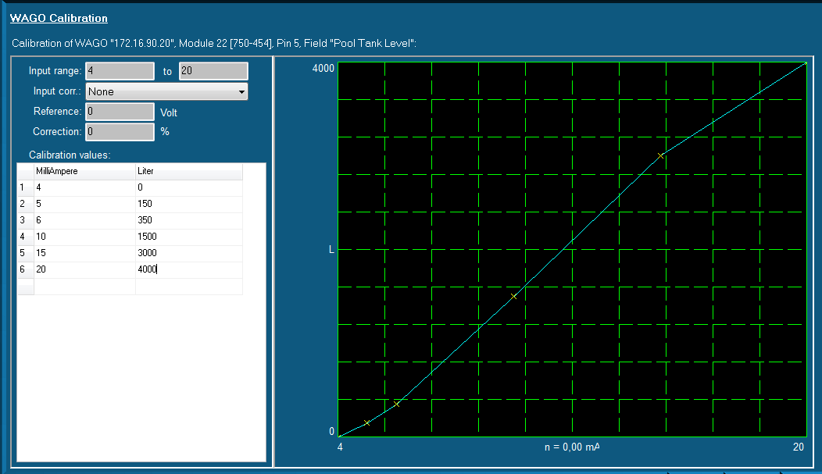

Figure 11‑60: Graph Calibrated

## Network

Under “Configuration > Network” the present network connections are shown (on right-hand side of window).

Select the IP-addresses of the network ports to use with the network server / client module (click and hold the Ctrl-key to select multiple network ports).

To confirm the settings, click “Accept and restart communications”.

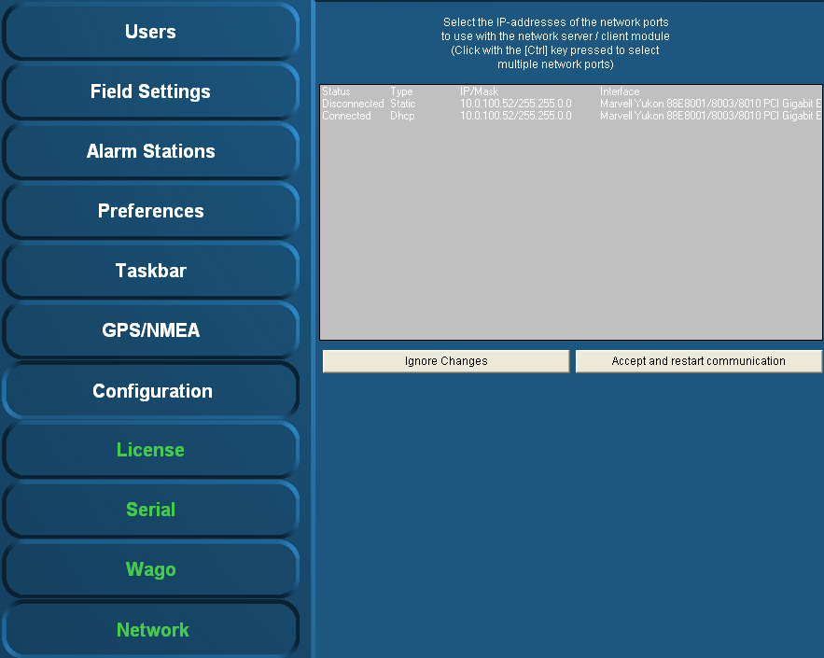

Figure 11‑61: Network

 *If there is no connection between server-clients or server-server, this is the most appropriate way to check. If the network ports aren’t selected here, there is no connection possible.   
Make sure that all the network ports are selected and then acknowledge via button “Accept and restart communications”.*

## System Layout

Will be implemented shortly.

## Soft PLC

### General

A PLC (programmable logic controller) is an electronic device with a microprocessor that, on the basis of its various inputs, controls its outputs. A good example is the Wago PLC that we use often with our system. To make it easier to use and also to extend the range to use it with, we developed a soft PLC for NavVision® . It is way beyond the scope of this manual to explain in depth the various ways to use this soft PLC, so we merely touch the handling features. For more information please refer to Free Technics and in the future to the Soft PLC Manual.

#### Basics

When you open Soft PLC for the first time you get an empty screen (see Figure 11‑62)

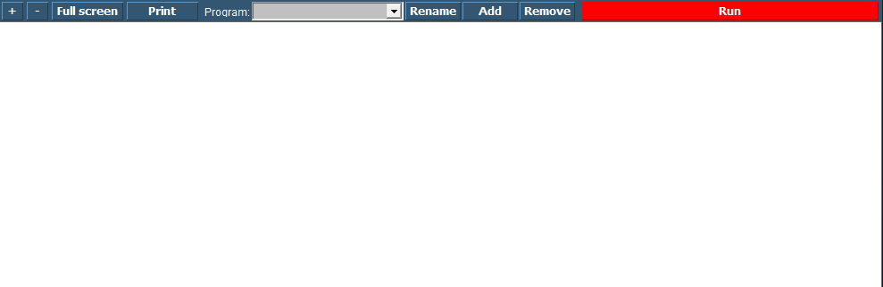

Figure 11‑62: Soft PLC

The following figures apply to the buttons on the screen:

|  |  |
| --- | --- |
| **Soft PLC Switch** | **Function** |
| +/- | Zoom in or out |
| Full Screen | Goto Fullscreen mode |
| Print | Print the Ladder Diagram |
| Program | Choose which PLC program you want to adjust by clicking the dropdown button |
| Rename | Rename the PLC program |
| Add | Add a new PLC program |
| Remove | Remove a PLC program |
| Run | Manually run or stop a specific PLC program |

### Simple example

Just to explain how it works, we will show a small example. This is merely to show how the diverse methods of implementing work in case you are already familiar with PLC programming.

#### Start

When you click “Add” you will start a new program. This program starts with an empty line an is called “SoftPLC1” if it is the first program you start. If you click “Rename” you can give it a distinctive name, which will pay off when you have a lot of PLC programs in your system (see Figure 11‑63).

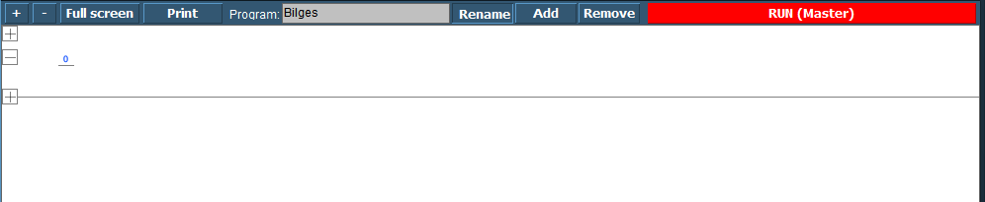

Figure 11‑63: SoftPLC Rename

Once you renamed it, you can go on with the program. For those familiar with PLC programming, you will recognize this as a ladder diagram. With the “+” you can add lines before or after and with “–“ you can remove the line.

We start this program with a bilge pump, which should run when a certain bilge alarm is high. When you click at the left side of the “0” a new pop-up appear with choices (see Figure 11‑64). These are beyond the scope of this manual to discuss, but if you know PLC programming, you will know what they are.

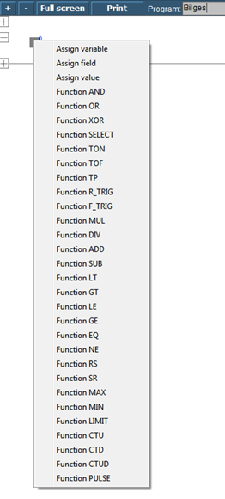

Figure 11‑64: SoftPLC pop-up

We choose for “Assign Field” to assign the Bilge Alarm as a trigger (see Figure 11‑65). Now we get into the FT part of the SoftPLC and we can work with this as we saw earlier in section 11.2. After choosing this field the PLC line will look as in Figure 11‑66

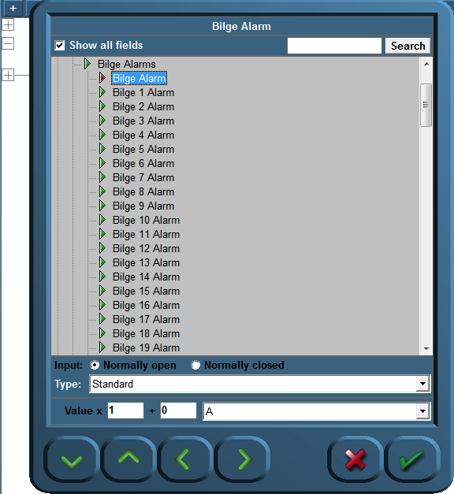

Figure 11‑65: SoftPLC Assign Field

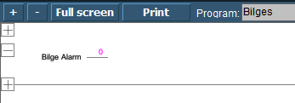

Figure 11‑66: SoftPLC first Line

We do the same at the right side of the “0” but this time we choose the Bilge Pump. We end up with a line like in Figure 11‑67.

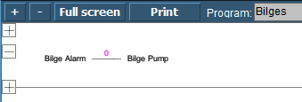

Figure 11‑67: SoftPLC First Line_2

So now when you press “Run” the program wll run and check the bilge alarm over and over. Once it gets high, the connection in the line gets high (1) and the Bilge Pump starts running until the alarm is not high anymore.

#### Control

You can understand that you can control the NavVision® installation much more once you use SoftPLC. You can make all kind of interactive switches and much more. If you want to know more about it, please contact Free Technics.

## Tank Tables

### General,

Each ship must have some kind of device to show the content of the divers tanks. Whether it is a glass tube, a pressure sensor, a capacitive sensor or a float unit, they are all designed to show the contents of the particular tank. While the first is a mechanical device, the rest is merely electrical.

The bigger ships will rely more on an accurate reading. Not only will they travel over longer distances, or need to be cost effective, they also often need to balance the ship by even things out in diverse ballast tanks. You can understand that the calibration of these sensors will have to be quite accurate.

### types of sensors

We will focus here on the electrical sensors as the mechanical ones gets more and more obsolete. The most used ones are

* The floating sensor
* The capacitive sensor
* The pressure sensor

#### Floating sensor

The floating sensor can be compared with the float unit that is used in toilets. These type of sensors are level-sensors. They measure how high (or low) the level of the fluid in the tank is. They can be equipped with a floating device connected to a hinged part, where the hinged part is electrically connected to a resistor which will give a voltage or milli-amperage that can be used to show the actual level of the liquid. The floating device can also be a magnetic ring attached around a pipe. For calibrating this device, please refer to section 11.10.6.

#### Capacitive sensor

The principle of capacitive level measurement is based on change of capacitance. An insulated electrode acts as one plate of capacitor and the tank wall (or reference electrode in a non-metallic vessel) acts as the other plate. The capacitance depends on the fluid level. An empty tank has a lower capacitance while a filled tank has a higher capacitance. While this is also a level measuring type it can be calibrated as told in section 11.10.6.

#### Pressure sensor

The pressure sensor is not a level indicator. It measures the liquid pressure (Pl) of the column of liquid above the sensor. In conjunction with the density of the liquid you can calculate the volume of the liquid. When the architect of the tanks has provided a sounding table, with the liquid pressure you can calculate the height of the liquid as well as the m3 of liquid. Again with the density you can calculate the mass (tonnage). You can see that this provides a very accurate and diverse scheme for the tanks that is very useful.

Within the NavVision ® system all this calculations are done automatically once you provided one of the variables. (see Figure 11‑68)

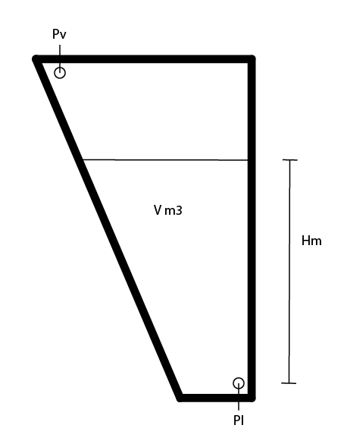

Figure 11‑68: Tank Pressure Sensor

|  |  |
| --- | --- |
| **Abrreviation** | **Explanation** |
| Pl | Liquid Pressure |
| Pv | Vent Pressure |
| V m3 | Volume in square meter |
| Hm | Height in meter |

Table 11‑1: Pressure sensor explanation

 *When not provided with a Pressure Vent Sensor it might give some strange irregularities. Especially when the vent-pipe is too small it will interfere with a good reading of the pressure sensor, while the air above the liquid column will be shifting all the time. It might then be necessary to place a Vent Pressure Sensor to even this out. Also this calculation is done automatically within NavVision ®.*

### 

### Inserting sounding tables

Under Configuration>Tank Tables you can find all the tanks. (see Figure 11‑69).

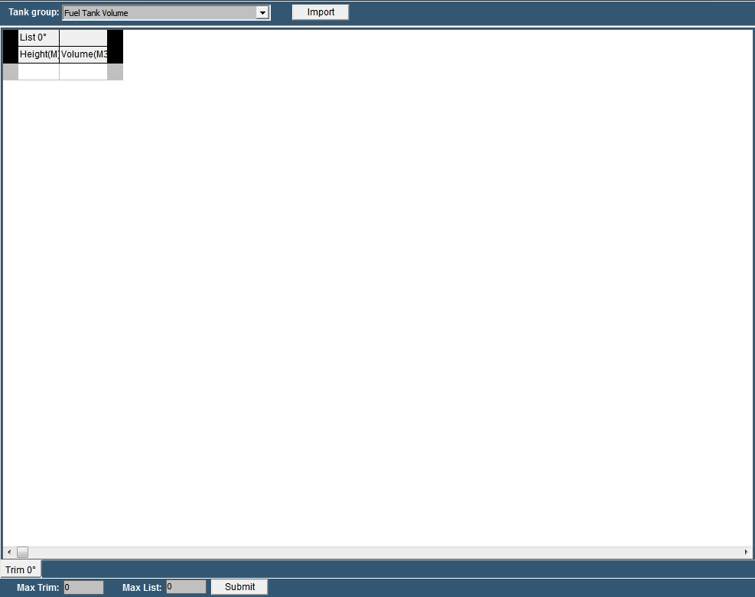

Figure 11‑69: Tank Tables

|  |  |
| --- | --- |
| **Detail** | **Description** |
| Tank Group | Find the tank you want to adjust a tank table for |
| Import | Import an Excel-sheet with sounding data |
| Max Trim | Max pitch (if provided in sounding table) |
| Max List | Max Roll (if provided in sounding table) |
| Submit | Submit Trim and List |

Table 11‑2: Tank Tables

#### Tank Group

In the drop down menu you can search for the tank that you are about to adjust. You will get all the tanks available. In this example we will use the Fuel Tank 1 Volume (see Figure 11‑70).

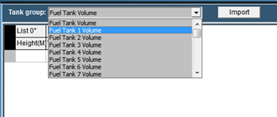

Figure 11‑70: Tank Group Drop Down

You’ll notice it only shows the tank group volumes, as that is what you get in the sounding table. As mentioned earlier with height and volume, NavVision ® can calculate all the other values.

Now that you have chosen the right tank, you can manually fill in the diverse heights and volumes. Make sure you start with “0” and end with the highest value or your value will be the wrong way around.

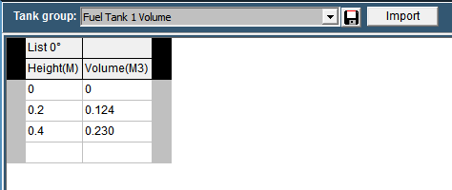

Figure 11‑71: Filling in tank tables

As soon as you start filling in the numbers you will see a “save button” appear next to the drop down menu (see Figure 11‑71). With this button you can save the calibration table to the specific tank. NavVision ® will immediately start working with this values.

Of course filling in large amounts of data like this will be quite time consuming. Therefor it is possible to import the data from an excel sheet providing the excel sheet is setup the right way.

#### Excel import

Most times the calibration tables or sounding tables will be available in some kind of excel format. It is wise to start with a new excel-sheet where you transfer the data from the sounding tables to, one by one. You can name the different tabs to the “trim” and “list” (see Figure 11‑72).

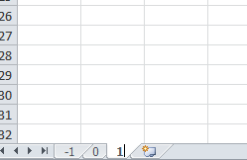

Figure 11‑72: Excel tabs

So for an example list we take the following sounding table:

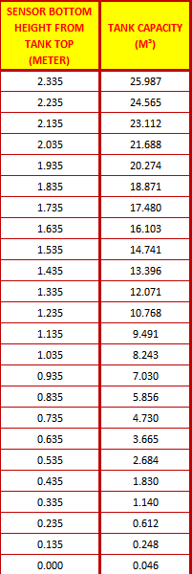

Figure 11‑73: Example Sounding Table

As you can see it goes from high to low, which is the wrong way around, but we change that later. First select all the values and “control-c” to copy the data. Go back to your original excel document and paste it on the SECOND row (see Figure 11‑74).

 *Use Paste Special “values” or “Unicode”*

 *In the first row you need to use an empty cell and the second cell with the “List” degree-number*

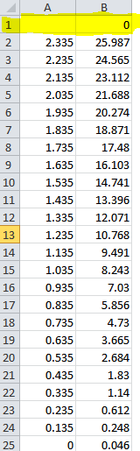

Figure 11‑74: Excel sheet import list

Now select all the values except for the upper row and choose “Sort>from low to high” to get the data in the right order. Once this is done you will have the right values for the list (see Figure 11‑75).

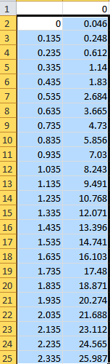

Figure 11‑75: Excel list sorted

Now save the new made table as “Excel97-2003 *.xls”file. In this case we name it “Fuel Tank 1”.

#### Import from excel

Now go back to the “tank tables” and click on “import”. Look for the excel file you just created and choose it for import. Click OK and the list will be imported and shown. (see Figure 11‑76).

At this time you can save the table and it will be used within the calculation of NavVision ®.

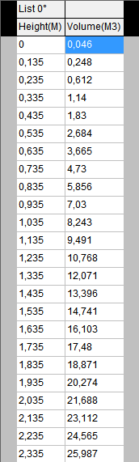

Figure 11‑76: Imported Table

### Trim and List

Ships move in different directions. They can roll over the latitude axis (the roll or list), or over the longitude axis (the pitch or trim). You can imagine that when the ship is moving, the liquids in the tanks will also move. This way the method of measuring with a pressure sensor will have some shortcomings.

For instance, when the ship is rolling over, the liquid column above the pressure sensor can alter. In this example it gets shorter (see Figure 11‑77). This way the calibration will alter. The pressure sensor thinks it has a smaller column of liquid and will refer to the calibration table. While the tank is abating here, there will be much more liquid available than the calibration table will say.

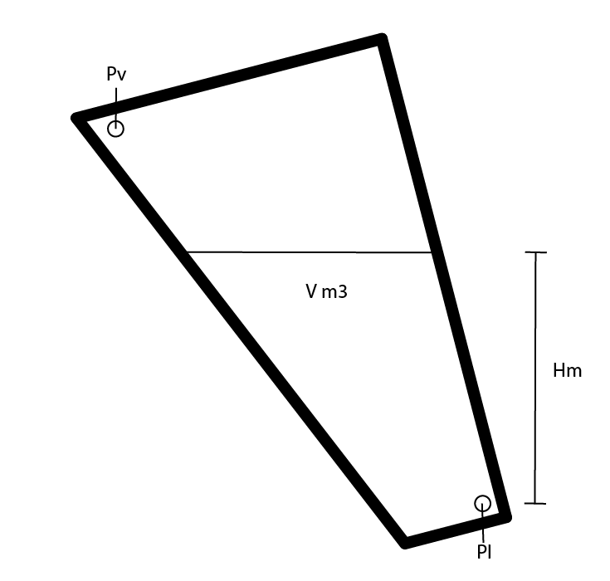

Figure 11‑77: Roll and Pitch

When an architect kept that in mind he surely will have the calibration or sounding table recalculated in different roll and pitch positions. This way you can make an even more accurate calibration.

#### Roll and Pitch in the Tank Table

In the tank table page you will find two “edit fields”. One for the Trim and one for the List. While Trim is the Pitch of the ship and List is the roll of the ship you can alter the number accordingly to the number of different sounding tables you have. If, let’s say, you have seven Trim Tables, fill in the number “3” and press “submit”. You’ll notice that there are now three tabs on either side of the 0-degree tab. -3,-2,-1,0,1,2 and 3 degree. (see Figure 11‑78). For this you need to have 7 different sounding tables from the architect.

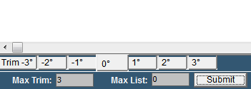

Figure 11‑78: Max Trim

Now let’s say that you have only three sounding tables for the roll (List). Fill in the number “1” and press “submit”. Now you will have three different columns for the sounding tables of the “List” -1,0 and 1 degree (see Figure 11‑79).

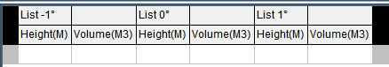

Figure 11‑79: Max List

This way you’ll have 3 different “list” columns for 7 different “trim” tabs so 21 different calibration points (see Figure 11‑80). In this ideal configuration you will have a very accurate calibration.

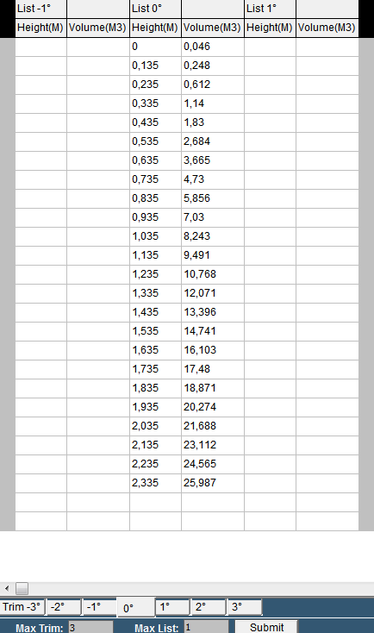

Figure 11‑80: Trim/List example

#### Trim and list in Excel

When you are importing sounding tables through an Excel list you would like to put in the trim and list at the same time. This is possible by doing the following:

Taken the previous as example you will have to make 7 tabs and rename them according to the degrees in the sounding table. For the trim you will make a column for each degree that you have in the sounding table and rename these in the upper row right cell of each separate column (see Figure 11‑81).

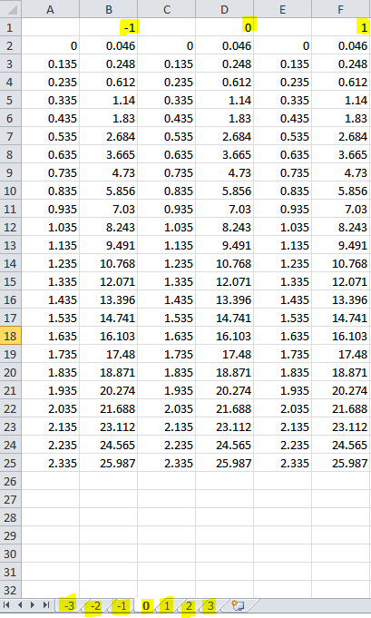

Figure 11‑81: trim and list excel example

Now save the excel sheet, import it in the tank table page, save it and you will have all the data ready to be used by NavVision ® (see Figure 11‑82)

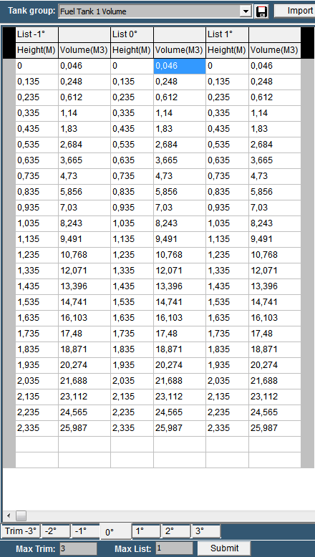

Figure 11‑82: Tank Table excel Trim and List import

## WatchIO

Will be implemented shortly.

## Logbook



Figure 11‑83: Logbook button

### General

During normal operation all system events will be registered chronologically. By clicking the “Logbook” button (see Figure 11‑83) these registered system events can be displayed.

In order to easily distinguish the displayed information, logbook reports are divided into colours. These colours are explained as follows:

#### Logbook colours

* **White**Reports to indicate the system is busy processing data
* **Green**Reports to confirm a certain system task is successfully completed
* **Red**Reports to indicate a system error has occurred or an alarm is set off
* **Orange**Reports to indicate a red report has been confirmed or that a white or green report hasbeen interrupted
* **Blue**Reports to indicate that parts of the system have been initialized.



Figure 11‑84: Logbook colours

### Logbook functionalities

The logbook has the following functionalities:

* Navigation/scroll buttons
* Time period
* Alarms from all stations
* Alarms
* Switching
* Network
* Serial communication
* System.

### Buttons

#### Scroll buttons

The scroll buttons are used to navigate through the logbook. The scroll buttons are explained as follows:



Figure 11‑85: Scroll buttons

|  |  |
| --- | --- |
| **Button** | **Description** |
| Scroll up/down (single) | To scroll up or down (one line at the time) the report list |
| Scroll up/down (double) | To scroll up or down (per page) the report list |
| Auto scroll | * ON The system event list is automatically scrolled with every new incoming event. * OFF The system event list freezes. |

#### Time period button

The “Time period” button allows you to define the view period (time frame) of all entries to be displayed.



Figure 11‑86: Time period button

#### Alarms from all stations button

By selecting the “Alarm from all stations” button all alarm messages are shown, that are monitored by NavVision® including the alarm messages not related to this alarm station.



Figure 11‑87: Alarms from all stations button

#### Alarm button

By selecting the “Alarm” button all assigned alarm station messages are shown.

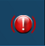

Figure 11‑88: Alarm button

#### Switching button

By means of the “Switching” button all fields that are being switched by NavVision® are displayed (i.e. hard/soft wired I/O or the switching of viewers).



Figure 11‑89: Switching button

A typical logbook entry is shown below (column “Message”):



* Field name e.g. “Viewer: Adjust Palette (Master)”
* Process name e.g. “Master” that switches the field
* “ON” or “OFF” status of the field being switched to.

#### Network button

Each Ethernet network connection will be logged under network entries.

The following is shown:

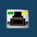

Figure 11‑90: Network button

* **White**  
  When a system tries to connect to a device
* **Green**  
  When the system successfully establishes a connection with a device
* **Red**  
  System fails to connect to a device or  
  Connection with a device has been interrupted or  
  General network error has occurred.

#### Serial communication button

By selecting the button “Serial communication” the history of all serial communication systems is shown.



Figure 11‑91: Serial communication button

* **White**  
  The system tries to create a (local) serial connection or initializes a serial protocol instance
* **Green**  
  The system successfully created a serial connection
* **Red**  
  A serial connection error has occurred.

#### System button

Via the “System” button system information messages in general are shown.



Figure 11‑92: System button

* **Green**  
  Successful process start
* **Red**  
  A serious problem has occurred in the process.

# Performance

### Preface

This section of the Operator Manual is for background information only. The Performance section does not contain essential information for the user to make full use of NavVision®.

### Modules

Under “F11 > Modules” the time period is shown that each NavVision® module uses in relation to the total NavVision® time.

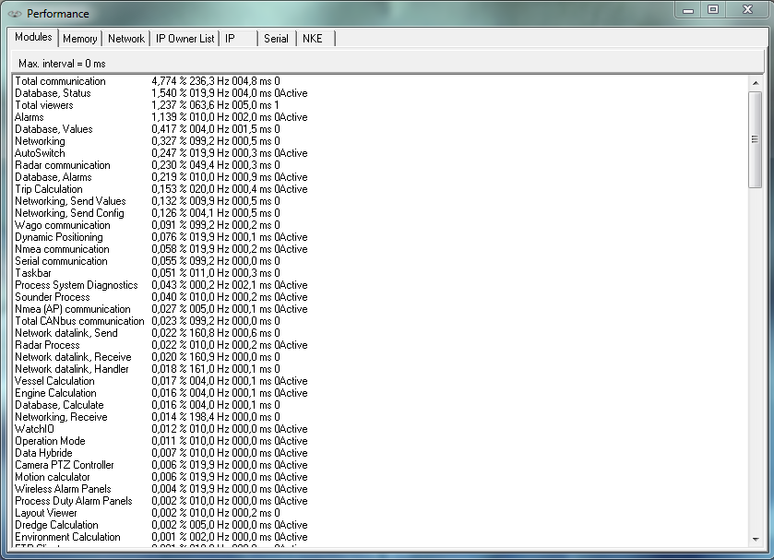

Figure 12‑1: Performance

The columns are arranged as follows:

|  |  |
| --- | --- |
| **Detail** | **Description** |
| Module Name | Internal name used by NavVision® to describe the module |
| Percentage | Percentage of processing time, where total NavVision® is 100% |
| Refresh Rate | Processing time in milliseconds |
| Total time | Total (module) processing time (in milliseconds) |
| Semaphore | Should be “0” or “1” |
| Active | Shows during refresh of screen |

### Memory

Under “F11 > Memory” developers can track for the presence of possible memory leaks.

By default the option “Activate memory manager” is disabled to avoid significant performance degradation.

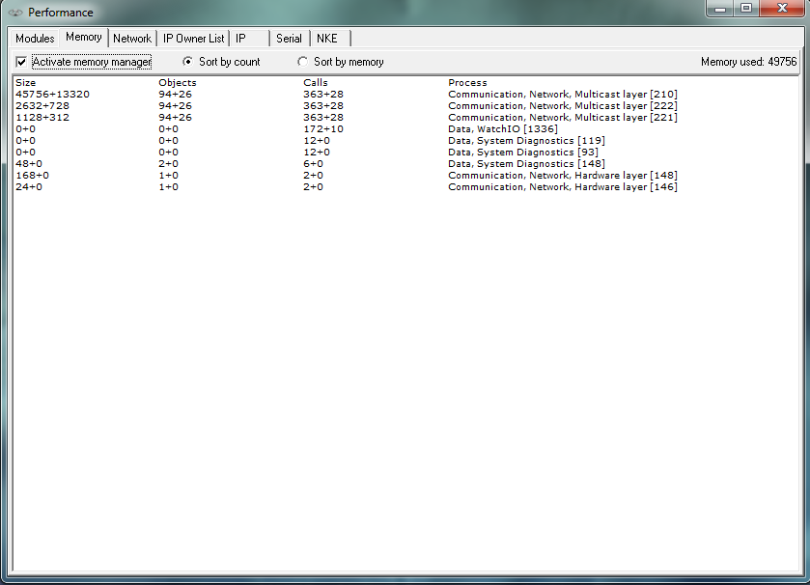

Figure 12‑2: Memory

The columns are arranged as follows:

|  |  |
| --- | --- |
| **Detail** | **Description** |
| Size | The size (bytes) of an object |
| Objects | Relative numberof objects created or deleted since activation of memory manager |
| Calls | Number of creation / deletion calls |
| Process | Process creating / deleting the objects |

 Take special notice of the “Memory Used” at the right top of the pane. If it keeps rising beyond your memory available, a memory leak is imminent.

### Network

Under “F11 > Network” the Connection to other workstations within the same system is shown. With all workstations connected and running, you will see your complete topology visible here.

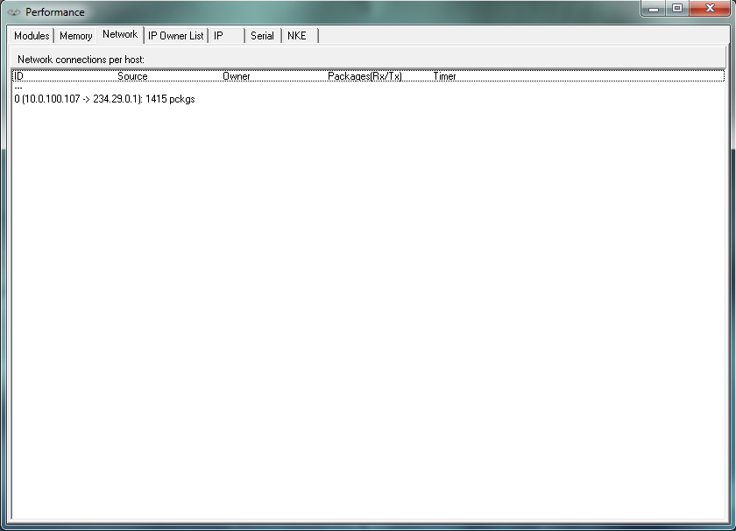

Figure 12‑3: Network

The columns are arranged as follows:

|  |  |
| --- | --- |
| **Detail** | **Description** |
| ID | Internal index used by NavVision®, not of importance in this list |
| Source | Active > when connected  Connect > when trying to connect  Closing > when closing the connection |
| Owner | UDP server, UDP client, TCP server or TCP client |
| Packages | The source of the connection. When “0.0.0.0:0” is shown, no source address was specified when opening the connection, where “0.0.0.0:x” means that port “x” on this computer is being used for server functionality |
| Timer | The destination of the connection |

### IP Owner List (which OWS is handling which ip’s)

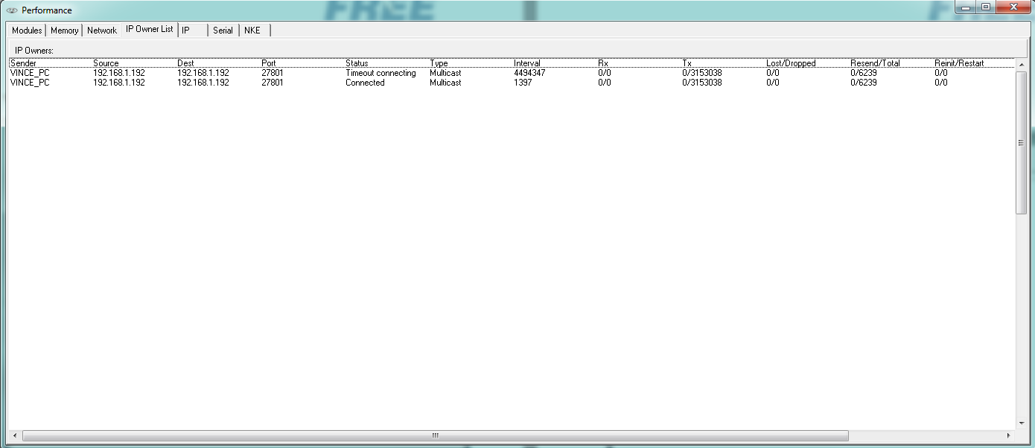

Figure 12‑4: IP Owners List

The columns are arranged as follows:

|  |  |
| --- | --- |
| **Detail** | **Description** |
| Sender | The workstation you are working on |
| Source | The workstation the connection is made from |
| Dest. | The interface that the source is (trying) to reach |
| Port | The port that is used for the connection |
| Status | The status of the connection |
| Type | Type of connection: Multicast, TCP, UDP |
| Interval | The interval between the last attempt |
| Rx | Receiving side |
| Tx | Transmitting side |
| Lost/Dropped | Packages lost/dropped |
| Resend/Total | Packages asked to be resend/total |
| Reinit/Restart | Reinitialisation/restart of the connection |

### IP

Under “F11 > IP” a list of all network connections as handled by the relevant NavVision® workstation is shown

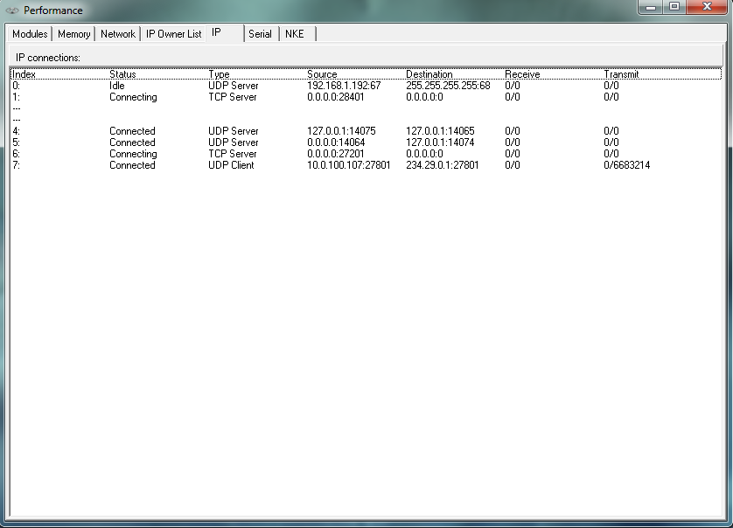

Figure 12‑5: Performance > IP

The columns are arranged as follows:

|  |  |
| --- | --- |
| **Detail** | **Description** |
| Index | Internal index used by NavVision®, not of importance in this list |
| Status | Active > when connected Connect > when trying to connect  Closing > when closing the connection  Idle > When doing nothing |
| Type | UDP server, UDP client, TCP server or TCP client |
| Source | The source of the connection. When “0.0.0.0:0” is shown, no source address was specified when opening the connection, where “0.0.0.0:x” means that port “x” on this computer is being used for server functionality |
| Destination | The destination of the connection |
| Receive | Number of Bytes left in the internal buffer / Number of bytes received |
| Transmit | Number of Bytes left in the internal buffer / Number of bytes sent |

### Serial

Under “F11 > Serial” the serial port status is indicated.

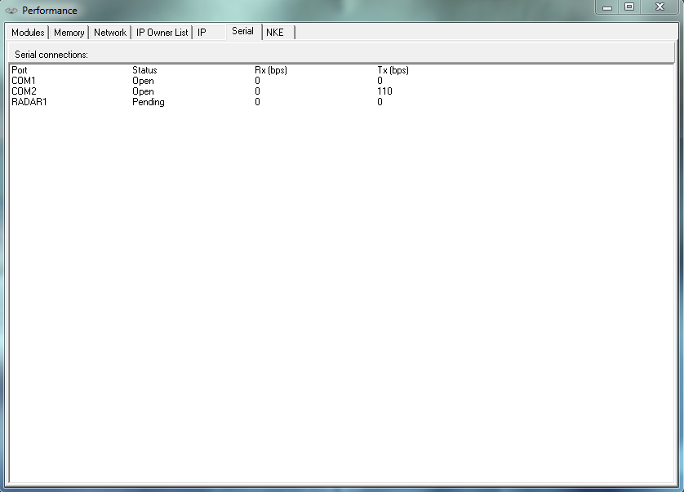

Figure 12‑6: Serial

The columns are arranged as follows:

|  |  |
| --- | --- |
| **Detail** | **Description** |
| Port | The serial port name. The possible radar port is also shown as a serial port, named “RADAR1”. When it is not used, the status stays on “Pending”. |
| Status | Serial port status i.e. “Failed”, “Pending”, “Closed” and “Open” |
| Rx (bps) | Number of bits “Received (Rx)” during the last second |
| Tx (bps) | Number of bits “Sent (Tx)” during the last second. |

For troubleshooting you can right-click on a serial port to see a pop-up you can click for additional data (See Figure 12‑7)

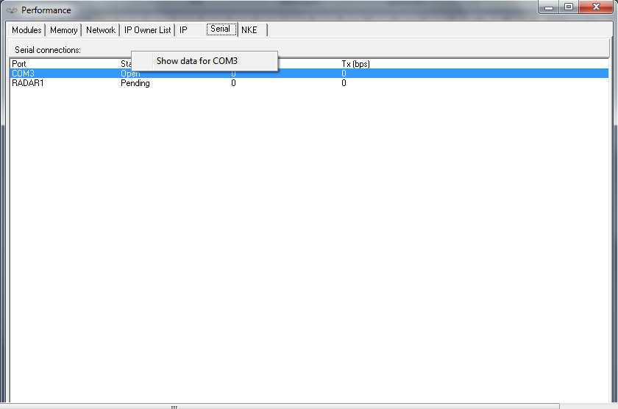

Figure 12‑7: Additional Serial Data

After clicking “show data for x” where x is the appropriate port, you will get a new pop-up field Communication Diagnostics. (see Figure 12‑9 and Figure 12‑9)

This tool you can use to troubleshoot data over serial ports. Here it shows all the data that is actually seen by NavVision® on the specific port.

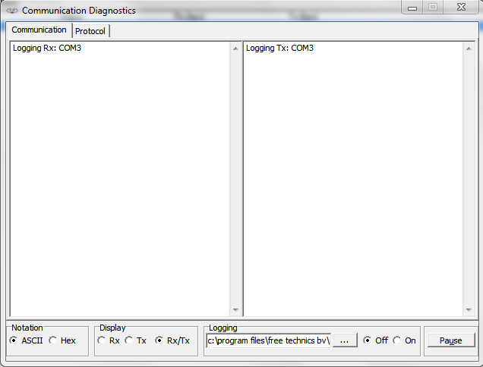

Figure 12‑8: Communication Diagnostics 1

|  |  |
| --- | --- |
| **Detail** | **Description** |
| Notation | Show data in ASCII or Hex |
| Display | Rx > Only show receiving side Tx> Only show transmitting side  Rx/Tx > Show receiving and transmitting side |
| Logging | Choose destination to save logfile and switch it off or on |
| Pause | Pause the data stream |

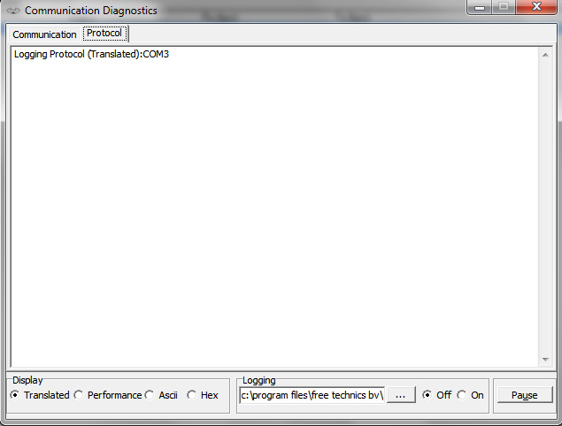

Figure 12‑9: Communication Diagnostics 2

|  |  |
| --- | --- |
| **Detail** | **Description** |
| Protocol | Shows the different protocols |
| Display | Translated > shows the data in readable output Performance > Shows the performance of the data  ASCII > Shows Data in ASCII  Hex > Shows Data in Hex |
| Logging | Choose destination to save logfile and switch it off or on |
| Pause | Pause the data stream |

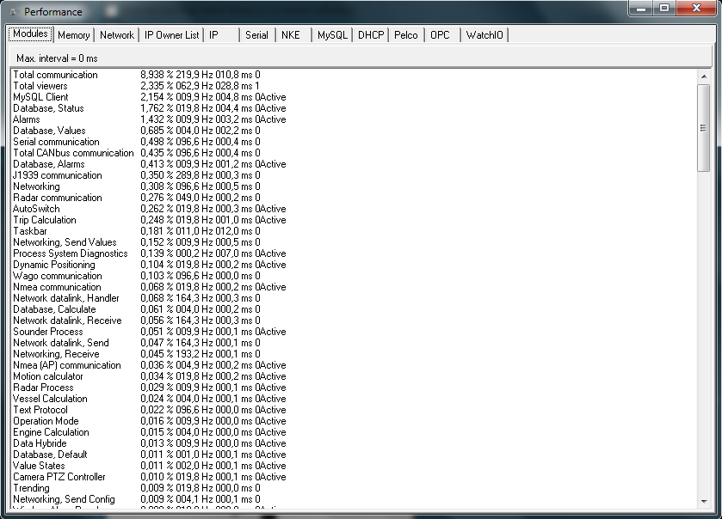

Figure 12‑10: Latest version

In the latest version there are a few new items added. These are however beyond the scope of this manual. Please feel free to explore them

1. DAP = Duty Alarm Panel
2. P&ID = Piping & Instrumentation Diagram
3. ACS = Automation Control Sequences
4. AMCS = Alarm, Monitoring and Control System
5. DM Timer = Dead Man’s Timer
6. Not part of the type approval process.
7. LED = Light Emitting Diode
8. DAP = Duty Alarm Panel
9. UTC = Universal Time Coordinated
10. Functionality only applicable with SMS hardware module + license